
Sri Lanka Institute of Information Technology
SE4040 – Enterprise Application Development

Smart Solar Microgrid Trading System
Project Design and Implementation Report
Assignment Report
Group ID - 12
Registration number | Name
IT22207272 | Fonseka G N V S
IT22228062 | Jayasinghe I A S A
IT22049872 | Navod W D C
IT22246332 | Hettiarachchi H A S L

Executive Summary
The Smart Solar Microgrid Trading System is a three-tier enterprise application that coordinates energy reservations between solar prosumers and microgrid operators. A React web interface supports Backoffice and Grid Operator work, a pure native Android application supports prosumer and field-operator workflows, and an ASP.NET Core 8 Web API centralizes authentication, authorization, business rules, QR processing and MongoDB persistence.
Repository analysis confirms the required FAT-service design: controllers map HTTP requests, services enforce the seven-day booking window, twelve-hour modification and cancellation notice, account activation controls, station deactivation guard, slot capacity, ownership and QR verification rules, while clients consume server decisions such as canModify, canCancel and isBookable. The data tier contains the four required MongoDB collections, and Android uses SQLite only for session and cache data.
The current local verification performed for this report successfully rebuilt the Android client and the React production bundle. The API and its recorded 90-assertion verification suite were not rerun because this Mac does not have the .NET SDK and does not currently have a working Mongo shell. The repository includes complete web screenshot evidence and diagram definitions, while Android screenshots, the demonstration video, member-specific contribution declarations and individual AI-use reflections remain submission actions for the group.
Layer | Technology | Primary responsibility
Web client | React 18, TypeScript, Tailwind CSS | Backoffice and Grid Operator user interface
Mobile client | Native Android Java, XML views, SQLite | Prosumer and field-operator user interface, local session and cache
Central service | ASP.NET Core 8 Web API | All business logic, security, validation, QR processing and client contract
Server data | MongoDB | Users, SolarStationInfo, EnergyBookingSlots and EnergyReservation

Contents
Executive Summary
1 Introduction
2 System Architecture
3 Database Design
4 Business Rules
5 Web Service
6 Web Application
7 Mobile Application
8 System Diagrams
9 User Interface Evidence
10 Testing and Verification
11 Deployment
12 Source Code Extracts
13 Individual Contributions and AI Disclosure
14 Challenges
15 References
Appendix A API Endpoint Catalogue
Appendix B Submission Readiness

1. Introduction

1.1 Purpose
The Smart Solar Microgrid Trading System lets owners of rooftop solar arrays - prosumers - trade surplus energy with a network of neighbourhood microgrid nodes. A prosumer reserves a time slot at a node, either to charge from the grid or to drop surplus energy into it. When a booking is approved the system issues a secure QR code; at the node a grid operator scans that code, the server verifies it, and the operator records how much energy actually moved.

1.2 Scope
The system comprises three deployable parts:
Part | Technology | Users
Central Web API | ASP.NET Core 8 (C#) on IIS, MongoDB | -
Web application | React 18, TypeScript, Tailwind CSS 3 | Backoffice officers, Grid operators
Mobile application | Pure native Android (Java), SQLite | Solar prosumers, Grid operators

1.3 Actors
- Backoffice officer - registers microgrid nodes, maintains their schedules,
creates web users, and is the only role permitted to activate or reactivate an account.
- Grid operator - works on both the web and the mobile client. Keeps battery bay
availability current, monitors bookings at their node, and finalises energy transfers in the field by scanning a prosumer's QR code.
- Solar prosumer - registers on the phone using their National Identity Card
number, reserves and manages energy slots, and reviews their transfer history.

2. System architecture

2.1 Overview
The system is a three-tier client-server application. The defining architectural constraint set by the assignment is the FAT service pattern: all business logic must reside in the central API, and both clients must act purely as user interfaces.
PRESENTATION TIER APPLICATION TIER DATA TIER
┌──────────────────┐ ┌────────────────────────┐ ┌──────────────┐
│ React 18 + TS │ │ ASP.NET Core 8 API │ │ MongoDB │
│ Tailwind CSS 3 │──── REST ─────▶│ │ │ │
│ │ + JWT │ Controllers (thin) │ │ Users │
│ Backoffice │ │ down │ │ SolarStat… │
│ Grid operators │ │ Services (FAT) │─────▶│ EnergyBook… │
└──────────────────┘ │ - rules R1-R13 │ │ EnergyRese… │
│ - Haversine distance │ │ │
┌──────────────────┐ │ - QR issue / verify │ └──────────────┘
│ Native Android │ │ down │
│ Java + SQLite │──── REST ─────▶│ MongoDbContext │
│ │ + JWT │ │
│ Prosumers │ │ Hosted on Windows IIS │
│ Grid operators │ └────────────────────────┘
└────────┬─────────┘
│
┌────▼─────┐
│ SQLite │ session + offline cache only - NOT the source of truth
└──────────┘

2.2 How the FAT service constraint is honoured
This was the single most important design decision, so it is worth stating precisely how it is enforced rather than merely asserted.
1. Controllers cannot hold logic. Every controller action is three lines: bind the DTO, call one service method, map the returned ServiceResult to an HTTP status code. There is not a single if statement over domain data in any controller. The mapping itself is a shared helper:
private ActionResult<ApiResponse<T>> Respond<T>(ServiceResult<T> result)
{
var body = result.IsSuccess
? ApiResponse<T>.Ok(result.Value, result.Message)
: ApiResponse<T>.Fail(result.Message, result.ErrorCode, result.Errors);
return result.Status switch
{
ResultStatus.Success => Ok(body),
ResultStatus.Created => StatusCode(StatusCodes.Status201Created, body),
ResultStatus.ValidationError => BadRequest(body),
ResultStatus.NotFound => NotFound(body),
ResultStatus.Conflict => Conflict(body),
ResultStatus.Forbidden => StatusCode(StatusCodes.Status403Forbidden, body),
ResultStatus.Unauthorized => Unauthorized(body),
_ => StatusCode(StatusCodes.Status500InternalServerError, body),
};
}
ServiceResult deliberately carries no ASP.NET types, so the service layer has no dependency on the web framework and could be reused by a different host unchanged.
2. The clients are given answers, not inputs to a rule. The clearest example is the 12-hour notice period. Rather than sending the clients a timestamp and trusting them to compare it, the API evaluates the rule per record and ships the verdict as two booleans:
var hoursUntilStart = (reservation.ReservationStartUtc - utcNow).TotalHours;
var isChangeableState = reservation.Status is ReservationStatus.Pending
or ReservationStatus.Approved;
var hasNotice = hoursUntilStart >= noticeHours;
CanModify = isChangeableState && hasNotice,
CanCancel = isChangeableState && hasNotice,
The React client writes disabled={!reservation.canCancel} and the Android client writes btnCancel.setEnabled(reservation.canCancel()). Neither ever computes an hour difference. The same pattern covers slot availability (isBookable).
3. Attempting the action anyway is still rejected. Disabling a button is a courtesy, not a control. Every rule is re-checked server-side on the write path, so a crafted request - or a stale page - is refused with the appropriate error code.
4. Neither client can reach the database. There is no MongoDB driver in either client project. The web application's only network dependency is axios; the Android application uses java.net.HttpURLConnection from the platform itself.

2.3 Request lifecycle
Client -> HTTPS request with Authorization: Bearer <JWT>
-> ExceptionHandlingMiddleware (catches anything unhandled, returns JSON)
-> MethodOverrideMiddleware (X-HTTP-Method-Override -> real verb)
-> UseRouting
-> Authentication (validates the JWT signature and lifetime)
-> Authorization ([Authorize(Roles = …)] on the action)
-> Controller action (binds DTO, model validation runs)
-> Service method (business rules; returns ServiceResult)
-> MongoDbContext (typed collection access)
-> MongoDB
<- ServiceResult -> ApiResponse envelope -> HTTP status code

2.4 The response envelope
Every endpoint - success or failure - returns the same JSON shape. Because the shape never varies, each client needs exactly one deserialiser and one error handler instead of one per endpoint:
{
"success": true,
"message": "Reservation created successfully. It is pending approval.",
"data": { },
"errorCode": null,
"errors": null,
"timestamp": "2026-09-05T15:33:32.374Z"
}
On failure errorCode carries a stable machine-readable identifier such as RES_CANCEL_12H. The clients branch on that code, never on the English message, so wording can change without breaking either client.

3. Database design

3.1 Choice of database
MongoDB was selected as required by the specification. It suits this domain well: a microgrid node's weekly schedule is a naturally nested array of seven day-records, and storing it as a sub-document avoids the join a relational design would need.
Database name: `SmartSolarMicrogridDb`. Four collections, exactly as the marking scheme specifies.

3.2 Collection: Users
Holds every principal - Backoffice officers, Grid Operators and Solar Prosumers. One collection keeps authentication uniform: a single lookup serves all three roles.
Field | Type | Notes
_id | ObjectId | Mongo identifier
nic | string | null | Prosumer primary key. Unique + sparse; null for staff
username | string | Unique. For prosumers the NIC is copied here
email | string | Unique + sparse
passwordHash | string | PBKDF2-SHA256, 100 000 iterations, base64
passwordSalt | string | 16 random bytes, base64, per account
fullName, phone, address | string | Profile
role | string | Backoffice | GridOperator | Prosumer
status | string | Pending | Active | Deactivated
deactivationRequested | bool | Raised by the prosumer from the mobile app
deactivationRequestedAt | date | UTC
deactivationReason | string | Free text
assignedStationId | string | Grid operator's home node
lastLoginAt | date | Set on each successful login
createdAt, updatedAt, createdBy, updatedBy |  | Audit

Indexes: nic (unique, sparse), username (unique), email (unique, sparse), {role, status} compound.
Why sparse? A unique index on nic would otherwise reject a second staff account,
because two documents with nic: null collide. Marking the index sparse excludes
documents that lack the field entirely, so the uniqueness guarantee applies only to
prosumers, which is exactly what the specification asks for.

3.3 Collection: SolarStationInfo
Field | Type | Notes
_id | ObjectId
stationCode | string | Unique, e.g. STN-001
name, address, city | string
type | string | Solar | Hybrid | Battery
location | object | { latitude, longitude } - GPS location
capacityKwh | double | Capacity specification (kW/h)
totalBatterySlots | int | Battery storage slots
availableBatterySlots | int | Maintained by the grid operator
operatingHours | object | { openTime, closeTime } as "HH:mm"
weeklySchedule | array | 7 x { dayOfWeek, isOpen, openTime, closeTime }
contactNumber | string
status | string | Active | Inactive

Indexes: stationCode (unique), status.

3.4 Collection: EnergyBookingSlots
Field | Type | Notes
_id | ObjectId
stationId | ObjectId ref | -> SolarStationInfo._id
stationCode, stationName | string | Denormalised for list screens
slotCode | string | S1, S2… unique within station + date
slotDate | date | UTC midnight of the slot's day
startTime, endTime | string | "08:00" - display only
startUtc, endUtc | date | Absolute instants; all rules compare on these
slotType | string | Charging | DropOff
energyCapacityKwh | double | Ceiling on a booking's energy
batterySlotNumber | int | Which physical bay
maxBookings | int | Normally 1
bookedCount | int | Maintained atomically with $inc
status | string | Available | Full | Blocked

Indexes: {stationId, slotDate, slotCode} (unique), startUtc, {stationId, status}.

3.5 Collection: EnergyReservation
Field | Type | Notes
_id | ObjectId
reservationNo | string | Unique, RSV-20260904-0001
prosumerNic | string ref | -> Users.nic
prosumerName, prosumerPhone | string | Denormalised
stationId, stationCode, stationName |  | Denormalised
slotId, slotCode
reservationStartUtc, reservationEndUtc | date | Rules R1/R2/R3 measure on these
startTime, endTime, slotType |  | Display
energyKwh | double | Requested
deliveredKwh | double | null | Captured by the operator at completion
status | string | Pending | Approved | Completed | Cancelled | Rejected
qrToken | string | null | 32 random bytes, URL-safe base64. Unique + sparse
qrPayload | string | null | Exact JSON encoded into the QR image
qrIssuedAt | date
approvedBy/At, completedBy/At, cancelledBy/At |  | Audit trail
cancelReason, rejectedReason, operatorNotes | string

Indexes: reservationNo (unique), qrToken (unique, sparse), {prosumerNic, reservationStartUtc}, {stationId, status, reservationStartUtc}.

3.6 Denormalisation
stationCode, stationName, prosumerName and prosumerPhone are copied onto the reservation at creation time. This is deliberate. Rendering a page of twenty bookings would otherwise require twenty additional lookups; with the copies it is a single query. The trade-off is that a renamed node must propagate, which StationService.UpdateAsync handles explicitly with an UpdateManyAsync over the affected slots and reservations.

3.7 Time handling
Every persisted instant is UTC. Slot wall-clock times are stored twice: as "HH:mm" strings for display, and as absolute startUtc / endUtc values. Every business rule compares only against the absolute values. The service layer never calls DateTime.UtcNow directly inside a rule; it reads the current instant from an injected IClock, which makes each rule testable with a frozen clock.

4. Business rules
All thirteen rules live in backend/SmartSolar.Api/Services/. Each returns a stable error code.
# | Rule | Error code | HTTP
R1 | A reservation must start in the future and within 7 days | RES_WINDOW_7_DAYS | 400
R2 | Updates require >= 12 hours notice, and status ∈ {Pending, Approved} | RES_UPDATE_12H | 400
R3 | Cancellations require >= 12 hours notice | RES_CANCEL_12H | 400
R4 | A node cannot be deactivated while it holds future Pending/Approved bookings | STATION_HAS_ACTIVE_RES | 409
R5 | A Deactivated account cannot log in; only Backoffice may reactivate | ACCOUNT_DEACTIVATED | 403
R6 | Self-registered prosumers start Pending and cannot log in until activated | ACCOUNT_PENDING | 403
R7 | NIC is unique across all accounts | NIC_ALREADY_EXISTS | 409
R8 | A slot must be Available, have capacity, be in the future, and its node active | SLOT_UNAVAILABLE | 409
R9 | A scanned QR must exist, be Approved, and fall within ±2 h of its window | QR_INVALID / QR_NOT_APPROVED / QR_OUT_OF_WINDOW | 400
R10 | Only Backoffice may manage web users and activate accounts | FORBIDDEN | 403
R11 | A prosumer may only read or modify their own data | FORBIDDEN | 403
R12 | A node closed on that weekday cannot be booked | STATION_CLOSED | 400
R13 | A prosumer may not hold two active bookings on one slot | DUPLICATE_RESERVATION | 409

4.1 The 7-day window (R1)
// ***RULE R1*** - the slot must start in the future and no more than the configured
// number of days ahead. Both bounds are checked against the injected clock so the rule
// can be unit tested with a frozen time.
if (slot.StartUtc <= now || slot.StartUtc > now.AddDays(WindowDays))
{
return ServiceResult<ReservationDto>.Invalid(
$"Reservations must be scheduled within the next {WindowDays} days and cannot be in the past.",
ErrorCodes.ReservationWindow);
}
The Android date picker also caps its maxDate at seven days out - but purely as a convenience. The comment in that code states explicitly that the API remains the authority and will reject anything outside the window regardless of what the picker allowed.

4.2 The 12-hour notice period (R2 / R3)
// ***RULE R3*** - a cancellation this close to the start time would strand a battery
// bay that can no longer be resold, so the service refuses it.
var hoursOfNotice = (reservation.ReservationStartUtc - _clock.UtcNow).TotalHours;
if (hoursOfNotice < NoticeHours)
{
return ServiceResult<ReservationDto>.Invalid(
$"Reservations can only be cancelled at least {NoticeHours} hours before the scheduled start time.",
ErrorCodes.ReservationCancelNotice);
}

4.3 The node deactivation guard (R4)
// ***RULE R4*** - a node holding Pending or Approved reservations that have not started
// yet cannot be taken out of service, because those prosumers have nowhere to go.
var activeCount = await CountActiveReservationsAsync(id, ct);
if (activeCount > 0)
{
return ServiceResult<StationDto>.Conflict(
$"This microgrid node cannot be deactivated because it still has {activeCount} " +
"active energy reservation(s). Cancel or complete them first.",
ErrorCodes.StationHasActiveReservations);
}
The same helper populates StationDto.ActiveReservationCount, so the web UI can warn the officer before they click - while the guard itself remains server-side.

4.4 Rule ordering
Rule order is itself a design decision. During testing, attempting a duplicate booking returned SLOT_UNAVAILABLE rather than DUPLICATE_RESERVATION: because a slot normally has maxBookings = 1, the prosumer's own first booking had already filled it, so the R8 capacity check fired before R13 could. The checks were reordered so R13 runs first, giving the caller the truthful message "You already hold an active reservation for this slot" instead of the misleading "this slot is full".

4.5 QR security (R9)
The QR payload is a compact JSON document:
{"v":1,"t":"<token>","r":"RSV-20260907-0007","n":"200356701199","s":"STN-001","e":"2026-09-07T16:00:00Z"}
The critical property is that the server trusts only the token. Every other field is re-read from MongoDB during verification. A tampered payload claiming a different reservation number or NIC changes nothing, because those values are never read from the scanned content. The scanner may post either the bare token or the whole payload; the service parses both:
// The scanned text may be the bare token or the entire JSON payload. Either is accepted,
// but only the token is trusted - every other field is re-read from the database, never
// taken from the scanned content.
var token = raw.Trim();
if (token.StartsWith('{'))
{
try
{
using var document = JsonDocument.Parse(token);
if (document.RootElement.TryGetProperty("t", out var tokenElement))
{
token = tokenElement.GetString() ?? token;
}
}
catch (JsonException)
{
// Not JSON after all - fall through and treat the whole string as the token.
}
}
On completion the token is cleared, so the same code cannot be scanned twice. If an approved booking is moved to a different slot, a fresh token is issued for the same reason - a previously screenshotted code must not be replayable against the new slot.

5. Web service (C# Web API)

5.1 Technology
Component | Choice | Reason
Framework | ASP.NET Core 8 (LTS) | Long-term support; first-class IIS hosting
Database driver | MongoDB.Driver 2.28 | Official driver
Authentication | JWT bearer, HMAC-SHA256 | Stateless; identical for both clients
Password hashing | PBKDF2-SHA256, 100 000 iterations | Recommended by Microsoft
QR generation | QRCoder 1.6 (PngByteQRCode) | Cross-platform; no System.Drawing
Documentation | Swashbuckle (Swagger UI) | Lets a marker exercise the API directly

A note on QRCoder. The obvious QRCode renderer depends on System.Drawing.Common,
which is Windows-only on .NET 8 and throws at runtime elsewhere. PngByteQRCode
produces the PNG bytes directly with no platform graphics dependency.

5.2 Project structure
SmartSolar.Api/
├── Controllers/ 7 thin controllers
├── Services/
│ ├── Interfaces/ IServices.cs - the entire service contract in one file
│ └── Implementations/
│ ├── AuthService.cs login, registration, password change
│ ├── UserService.cs Backoffice / GridOperator accounts
│ ├── ProsumerService.cs prosumers, keyed by NIC
│ ├── StationService.cs nodes, schedules, Haversine "nearby"
│ ├── SlotService.cs slots, bulk generation
│ ├── ReservationService.cs the booking workflow and QR lifecycle
│ ├── QrCodeGenerator.cs PNG rendering, token creation
│ └── DomainMapper.cs entity -> DTO projections
├── Models/ The four MongoDB documents + enums
├── DTOs/ Request/response contracts with validation attributes
├── Data/ MongoDbContext (indexes), DataSeeder
├── Security/ PasswordHasher, JwtTokenService, CurrentUser
├── Middleware/ ExceptionHandling, MethodOverride
└── web.config IIS / ASP.NET Core Module configuration

5.3 Authentication and authorisation
Login accepts a NIC, a username or an e-mail address in one field. The lookup uses an anchored, case-insensitive regular expression, with the user's input escaped first so regex metacharacters cannot be injected:
// The identifier is escaped before it becomes part of a regex so a user cannot inject
// regex metacharacters, and anchored so it matches the whole field rather than a substring.
var pattern = new BsonRegularExpression($"^{Regex.Escape(identifier)}$", "i");
Both "user not found" and "wrong password" return the same message, so the endpoint does not disclose which accounts exist.
Successful login issues a JWT valid for eight hours carrying the user id, username, role, NIC and assigned station. ClockSkew is set to zero so an expired token is rejected immediately rather than up to five minutes later.

5.4 Server-side distance calculation
The "nearby nodes" feature is a good illustration of the FAT-service rule. It would be easy to send the client every node and let it compute distances - and that is exactly what the constraint forbids. The Haversine formula runs in StationService:
/// <summary>
/// Great circle distance between two GPS positions using the Haversine formula.
/// This runs on the SERVER, not in a client, because ranking nodes by proximity is
/// business logic and the FAT-service pattern keeps all of it in the API.
/// </summary>
private static double HaversineKm(double lat1, double lon1, double lat2, double lon2)
{
const double earthRadiusKm = 6371.0;
var dLat = ToRadians(lat2 - lat1);
var dLon = ToRadians(lon2 - lon1);
var a = Math.Sin(dLat / 2) * Math.Sin(dLat / 2)
+ Math.Cos(ToRadians(lat1)) * Math.Cos(ToRadians(lat2))
* Math.Sin(dLon / 2) * Math.Sin(dLon / 2);
return earthRadiusKm * 2 * Math.Atan2(Math.Sqrt(a), Math.Sqrt(1 - a));
}

5.5 Concurrency
bookedCount is maintained with MongoDB's atomic $inc rather than a read-modify-write:
// Inc is atomic in MongoDB, so two prosumers booking the last place on the same slot at
// the same moment cannot both read a stale count and both succeed.
var update = Builders<EnergyBookingSlot>.Update.Inc(s => s.BookedCount, delta);
await _db.Slots.UpdateOneAsync(filter, update, cancellationToken: ct);

5.6 Endpoint summary
Base path /api/v1. 56 endpoints across seven controllers.
Controller | Endpoints
AuthController | login, register, me, change-password
UsersController | list, get, create, update, activate, deactivate, reset-password, delete
ProsumersController | list, pending, get by NIC, create, update, activate, deactivate, request-deactivation, delete
StationsController | list, nearby, get, create, update, schedule, availability, activate, deactivate, delete
SlotsController | list, available, get, create, generate, update, block, delete
ReservationsController | list, my, history, dashboard, get, qr, create, update, cancel, approve, reject, verify-qr, complete
HealthController | health

Full request and response shapes are documented in docs/API_CONTRACT.md.

6. Web application

6.1 Technology
React 18 + TypeScript + Vite, styled with Tailwind CSS 3. Routing with React Router 6, HTTP with axios, charts with Recharts, maps with Leaflet + OpenStreetMap.
Why Leaflet rather than Google Maps on the web? The Google Maps JavaScript API
requires a billing-enabled key. Leaflet with OpenStreetMap tiles needs no key at all,
so the map screen works on any machine the project is opened on - including a marker's.
Google Maps is used on the Android client, where the specification requires it.

6.2 Structure
web/src/
├── api/
│ ├── client.ts axios instance, interceptors, ApiError, envelope unwrapper
│ └── services.ts one typed function per endpoint
├── components/
│ ├── ui.tsx Spinner, Modal, ConfirmDialog, Toast, StatCard, Pagination…
│ ├── Layout.tsx sidebar shell, role-filtered navigation, live API health dot
│ └── ProtectedRoute.tsx
├── context/AuthContext.tsx
├── pages/ 12 screens
├── types/index.ts TypeScript mirrors of every API DTO
└── utils/format.ts date and badge helpers

6.3 Error handling
A single response interceptor turns every failure into a typed ApiError, so each screen has exactly one thing to catch:
http.interceptors.response.use(
(response) => response,
(error: AxiosError<ApiResponse<unknown>>) => {
// No response at all means DNS, CORS, a timeout or a stopped API.
if (!error.response) {
return Promise.reject(new ApiError(
'Could not reach the Smart Solar service. Please confirm the API is running.',
0, 'NETWORK_ERROR'));
}
const { status, data } = error.response;
return Promise.reject(new ApiError(
data?.message ?? `The request failed with HTTP ${status}.`,
status, data?.errorCode ?? null, data?.errors ?? null));
},
);

6.4 Screens
Route | Screen | Roles
/ | Public landing page | anyone
/login | Sign in, role-based redirect | anyone
/dashboard | Live counters, status chart, upcoming bookings | all
/reservations | Filterable list; approve, reject, cancel | all
/reservations/:id | Detail, QR panel, audit trail | owner / staff
/stations | Node cards; edit, schedule, availability, activate | all (edit: Backoffice)
/slots | Slot table; create, bulk generate, block, delete | Backoffice, Operator
/prosumers | Prosumer list keyed by NIC | Backoffice, Operator
/prosumers/pending | Pending-activation queue | Backoffice
/users | Web user administration | Backoffice
/map | Leaflet map of all nodes | all
/profile | Own profile, password change | all

7. Mobile application

7.1 Compliance with the "pure native" constraint
The specification requires pure native Android with SQLite and forbids cross-platform frameworks. The project honours this strictly:
Concern | Choice | Deliberately not used
Language | Java | Kotlin
Views | XML layouts + findViewById | View binding, data binding, Compose
Networking | java.net.HttpURLConnection | Retrofit, OkHttp, Volley
JSON | org.json (bundled with Android) | Gson, Jackson, Moshi
Persistence | SQLiteOpenHelper | Room, any ORM
Concurrency | ExecutorService + Handler | RxJava, Coroutines
Dependency injection | Plain constructors | Dagger, Hilt

The only third-party artefacts are AndroidX/Material (Google's standard UI toolkit), play-services-maps and play-services-location (required by the specification for maps), and zxing-android-embedded (required for QR scanning). These are libraries, not application frameworks.

7.2 Networking
ApiClient wraps HttpURLConnection, runs requests on a fixed thread pool, and posts results back to the main looper so activities can touch views directly:
private void enqueue(final String method, final String path, final JSONObject body,
final String token, final Callback callback) {
// A connectivity check up front turns a 20 second timeout into an instant message.
if (!isOnline()) {
MAIN_HANDLER.post(() -> callback.onResult(
ApiResult.networkFailure("No internet connection. Please check your network and try again.")));
return;
}
EXECUTOR.execute(() -> {
final ApiResult result = execute(method, path, body, token);
MAIN_HANDLER.post(() -> callback.onResult(result));
});
}

7.3 SQLite
Four tables, created directly through SQLiteOpenHelper:
Table | Purpose
session | The signed-in user and their JWT - a single row
stations | Cached microgrid nodes for the map and pickers
reservations | Cached bookings for the list screens
sync_log | Audit of what was cached and when

The assignment asks specifically that login details persist in SQLite, so the token and profile are written to the session table rather than to SharedPreferences. The splash screen reads that row to decide whether to show the login form or go straight to a role home screen.
SQLite is a cache and session store, never the authority. When a list loads successfully it is cached; if a later request fails with a network error the cached rows are shown together with a visible "showing saved data" banner. Every write - create, update, cancel, approve, complete - goes straight to the API.

7.4 Screens
Activity | Purpose
SplashActivity | Reads the SQLite session, routes by role
LoginActivity | Sign in; handles ACCOUNT_PENDING / ACCOUNT_DEACTIVATED distinctly
RegisterActivity | Prosumer self-registration with NIC as primary key
ProsumerHomeActivity | Dashboard: live counts, quick actions, upcoming bookings
OperatorHomeActivity | Operator console scoped to the assigned node
NewBookingActivity | Node -> date -> slot -> energy booking flow
MyBookingsActivity | Current / Pending / History tabs plus search
BookingDetailActivity | Detail, QR display, edit and cancel gated on server flags
EditBookingActivity | Move slot or change energy
BookingSummaryActivity | The summary page shown after every action
StationsMapActivity | Google Maps with nearby nodes ranked by the API
StationDetailActivity | Node details on marker selection
ScannerActivity | QR scanning with ZXing
VerifyResultActivity | Verified booking, then finalise the transfer
OperatorBookingsActivity | Node bookings with status filter and debounced search
ProfileActivity | Edit profile, change password, request deactivation

8 System Diagrams
The diagrams below are rendered from the version-controlled Mermaid definitions in docs/diagrams/DIAGRAMS.md. Together they show deployment boundaries, actor responsibilities, data movement, collection relationships and the reservation and QR workflows.
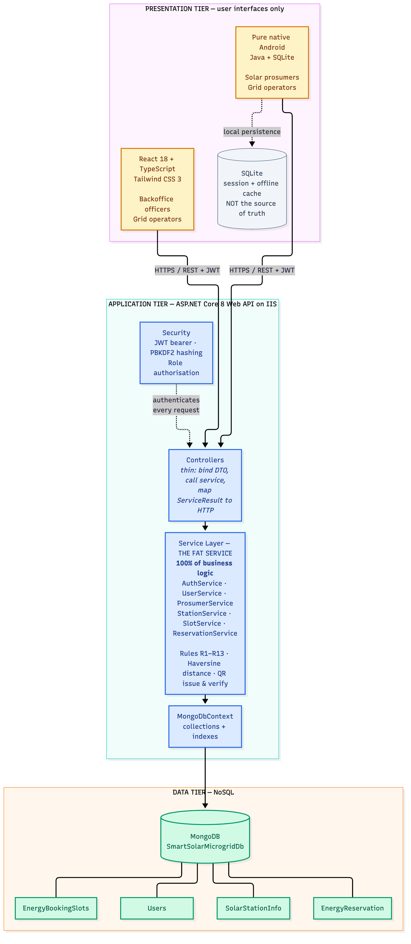
Figure 1. High Level Architecture Diagram

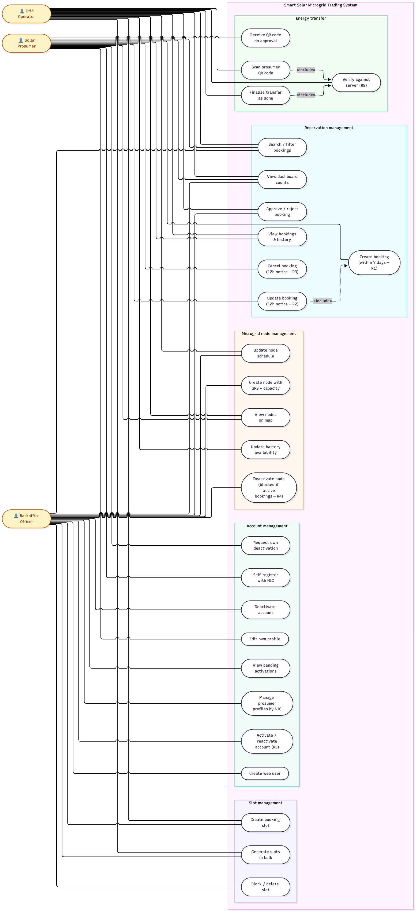
Figure 2. Use Case Diagram

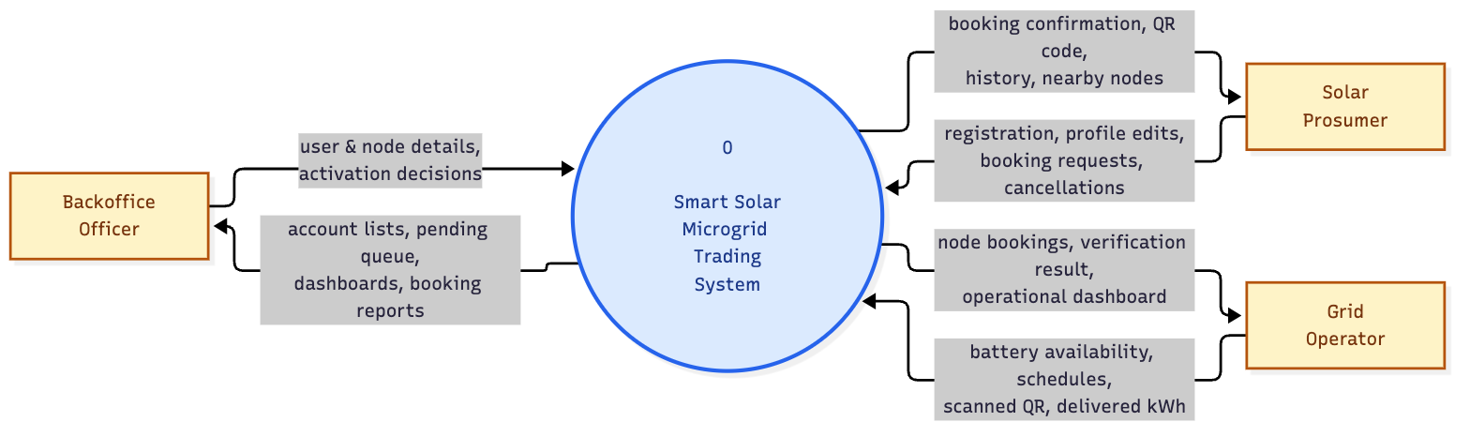
Figure 3. Data Flow Diagram Level 0 Context Diagram

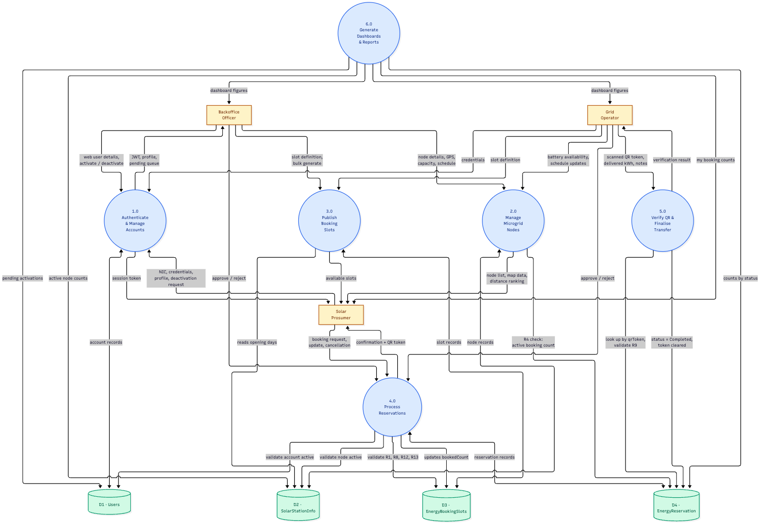
Figure 4. Data Flow Diagram Level 1

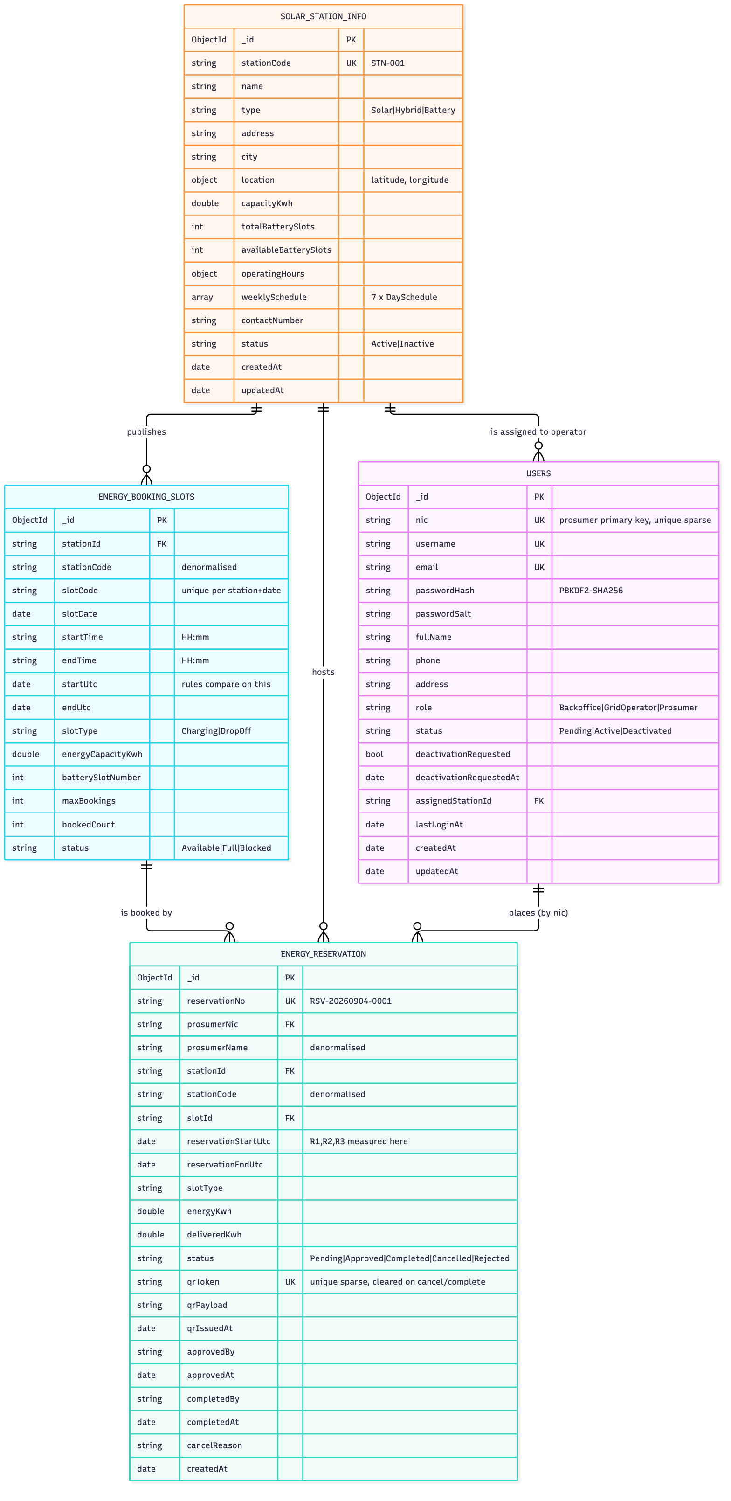
Figure 5. Database Design Collection Relationships

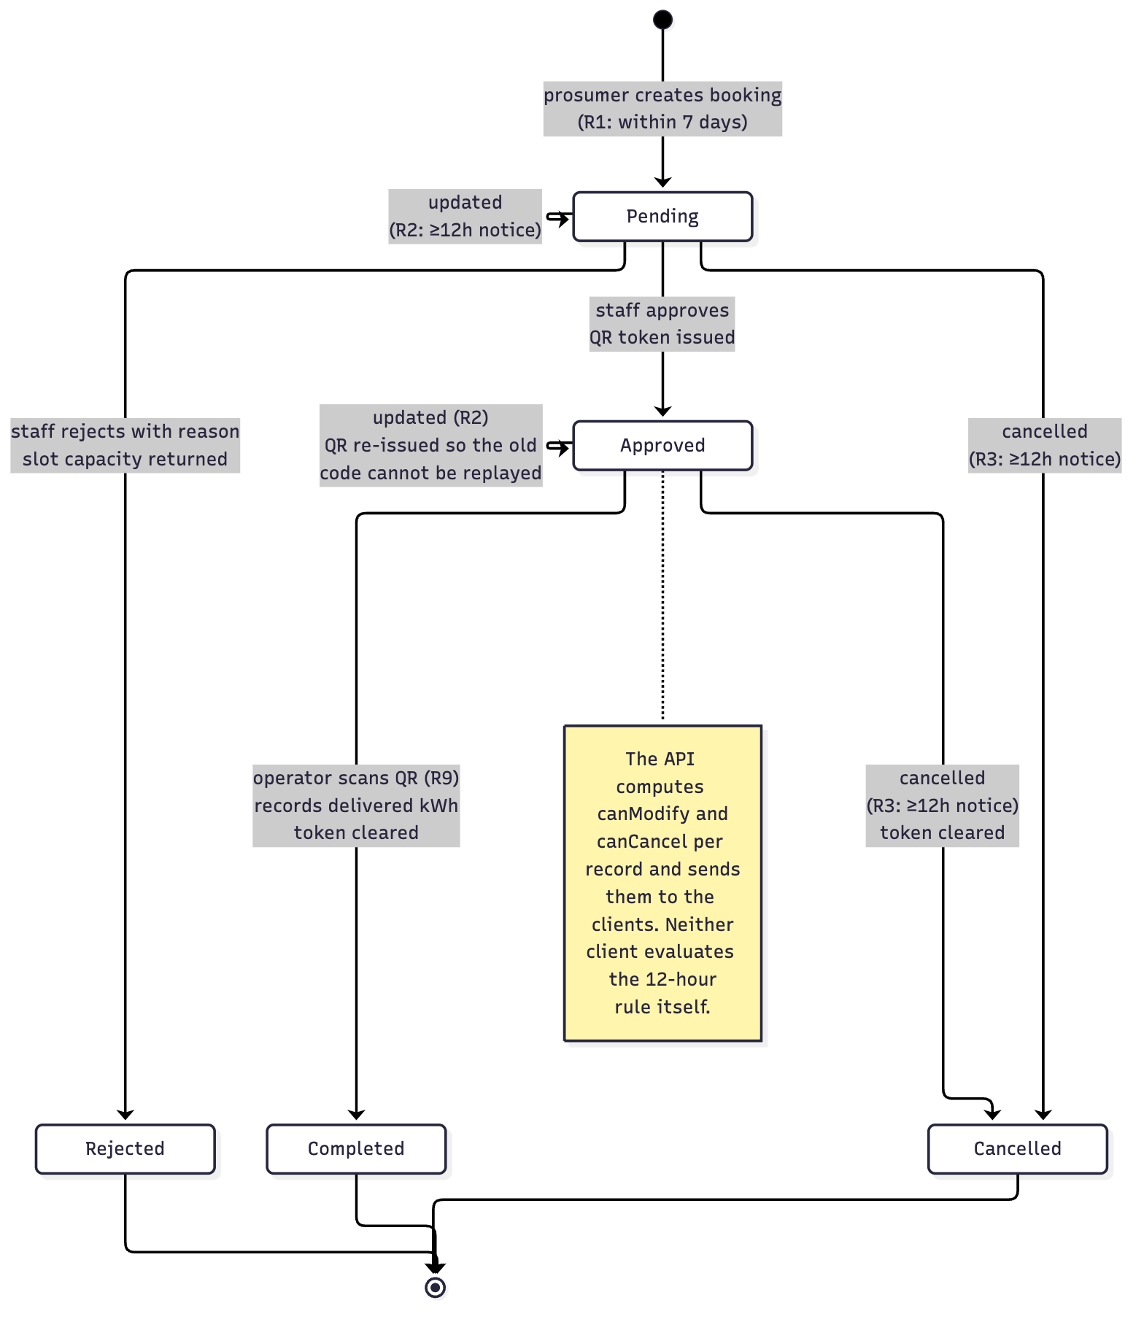
Figure 6. Reservation Life Cycle State Diagram

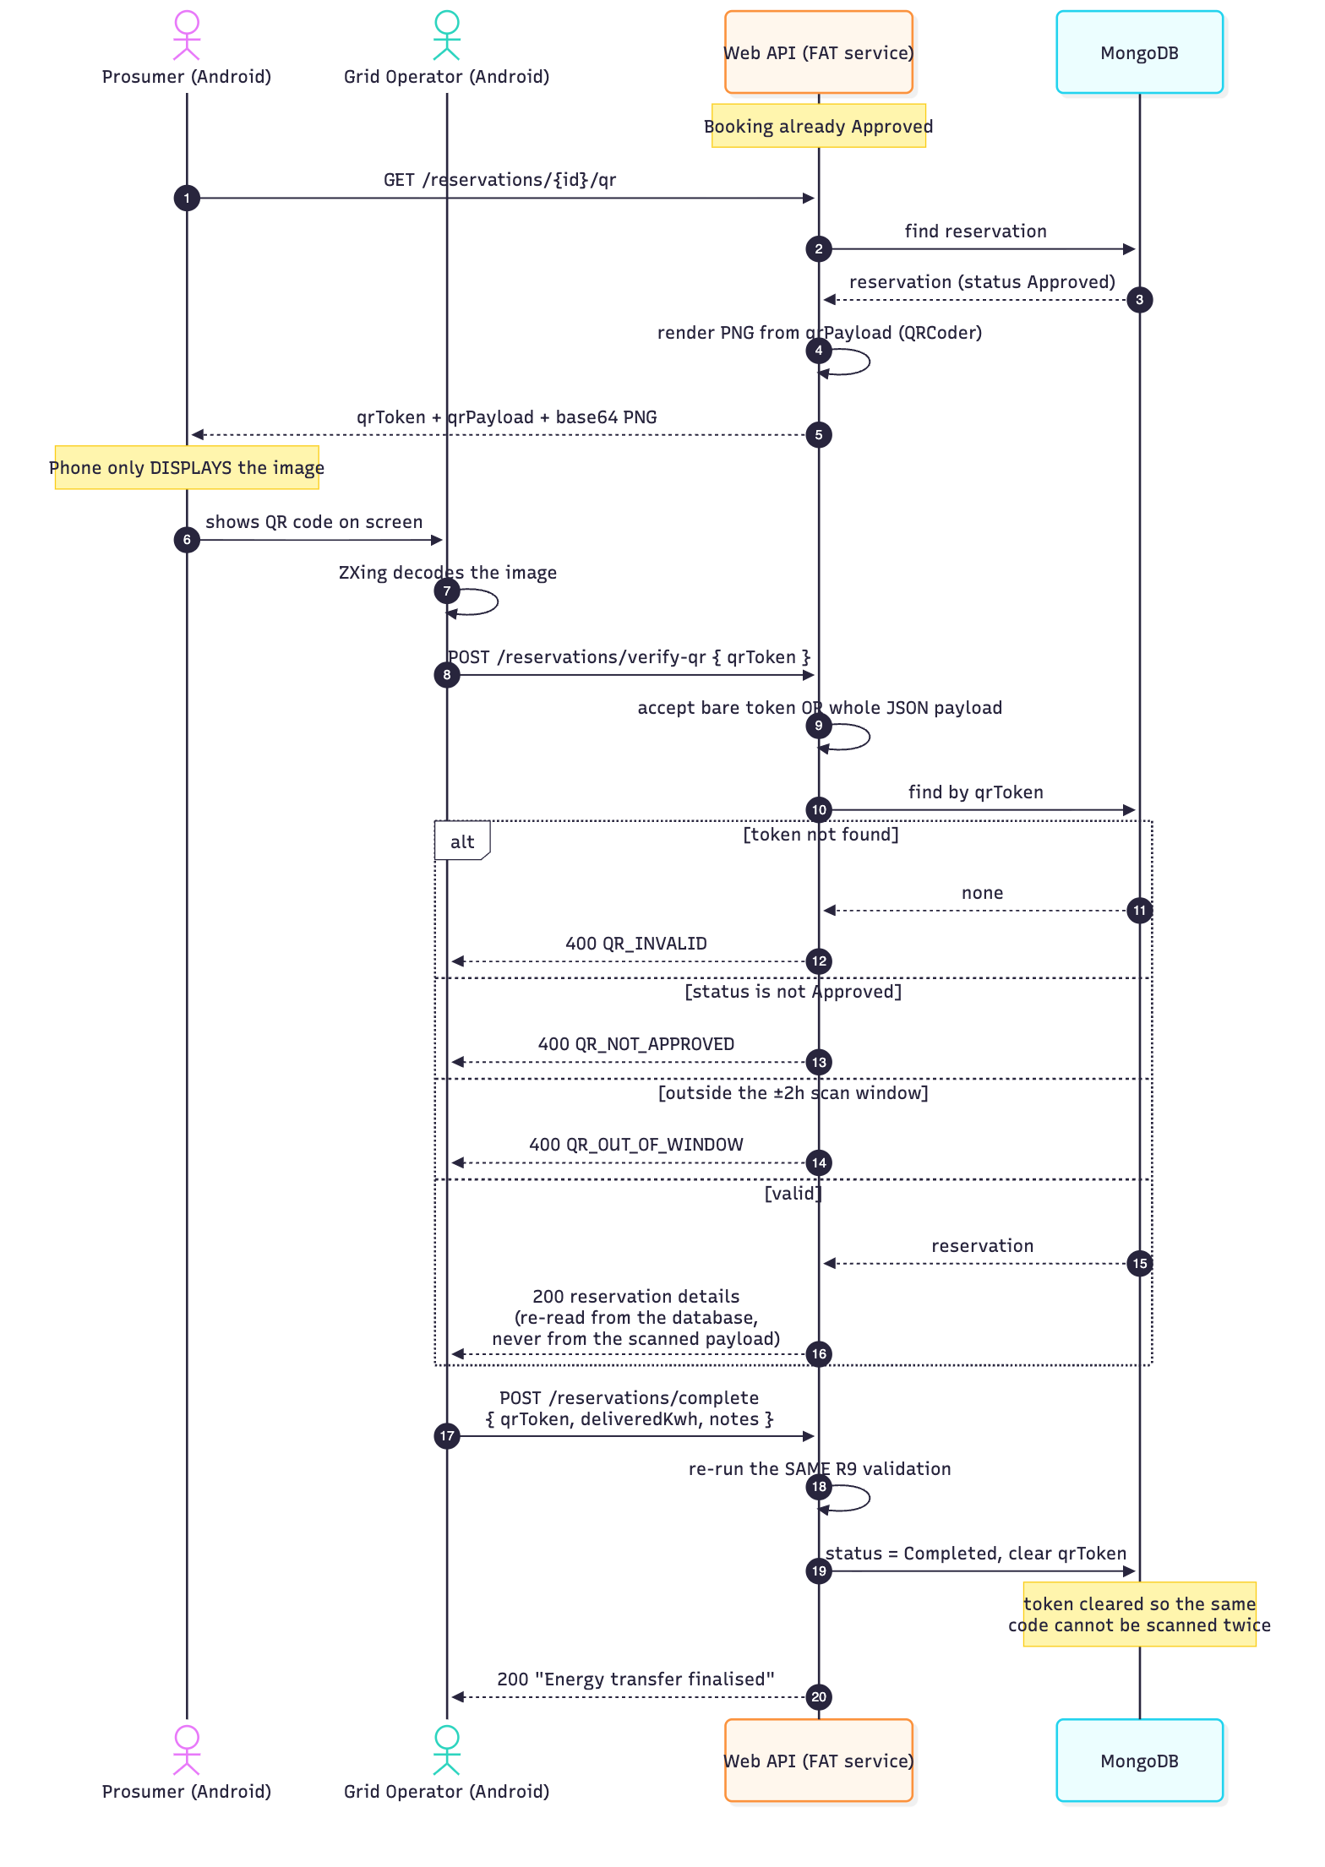
Figure 7. Qr Verification Sequence

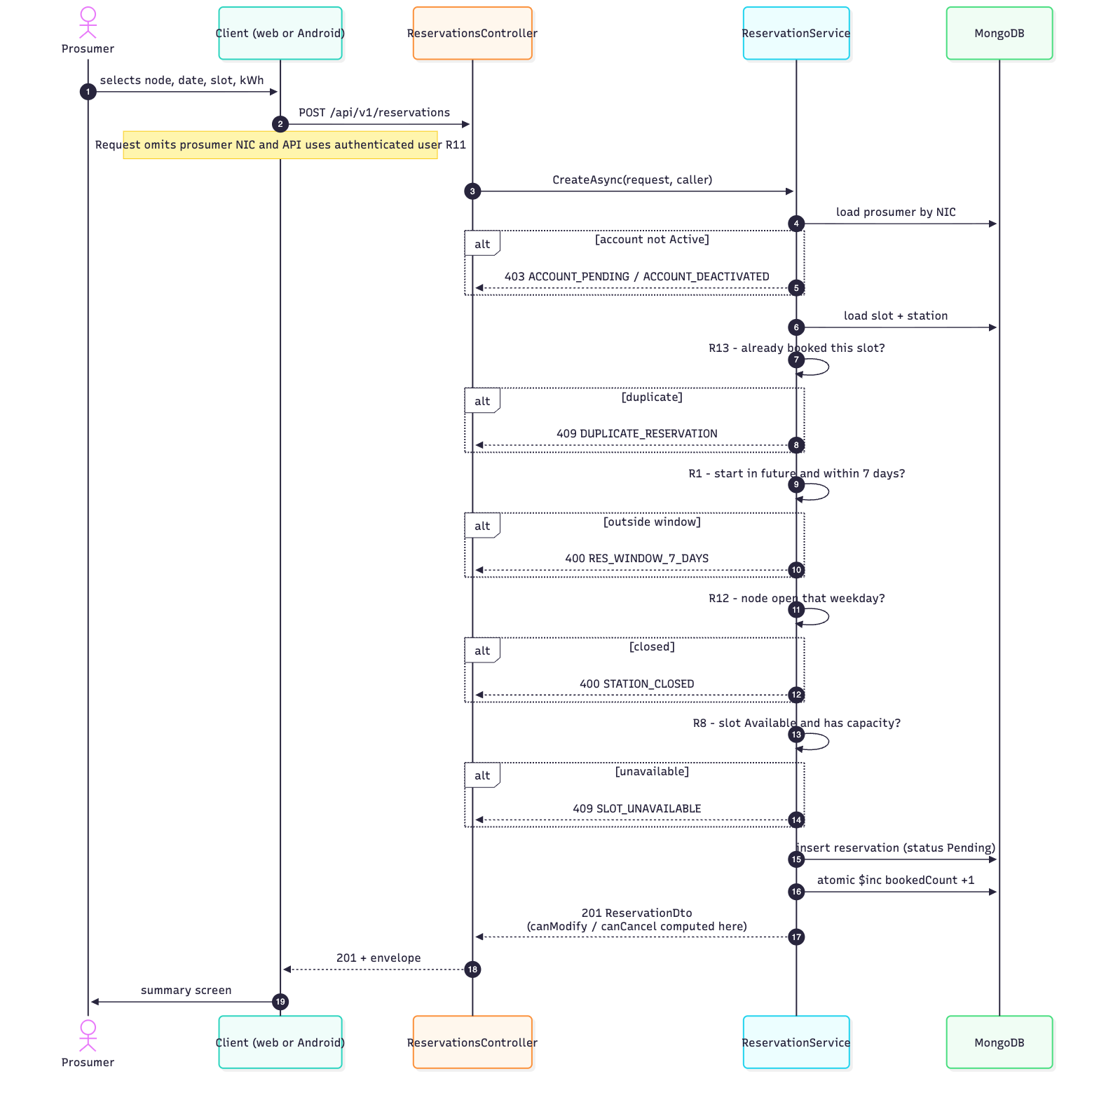
Figure 8. Booking Creation Sequence Showing Where Each Rule Fires

9 User Interface Evidence

9.1 Web Application
The following images are the unique web-interface captures stored in docs/screenshots/web. They cover the public entry point, authentication, role-specific dashboards, booking operations, account administration, mapping and responsive behavior.
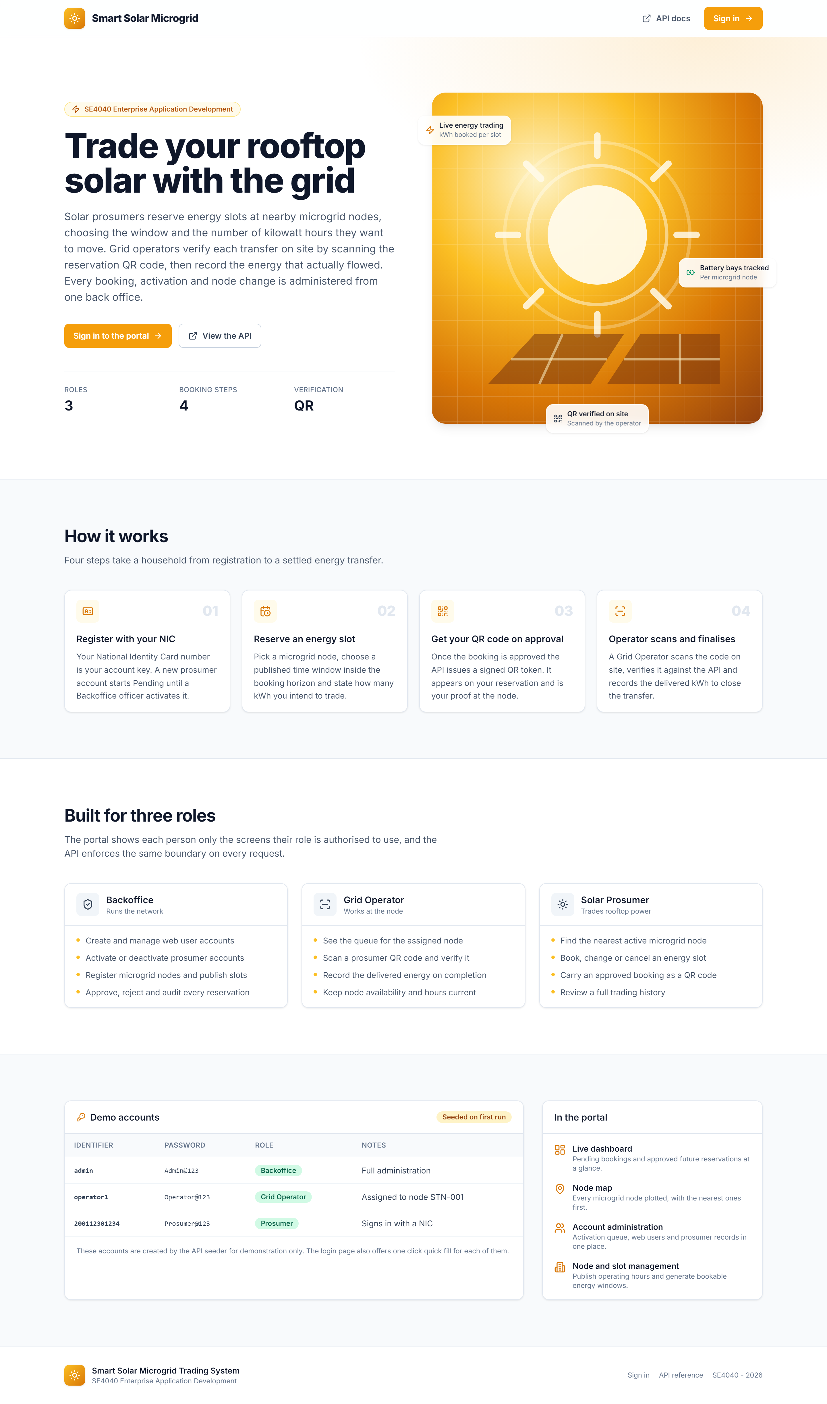
Figure 9. Public landing page and project overview

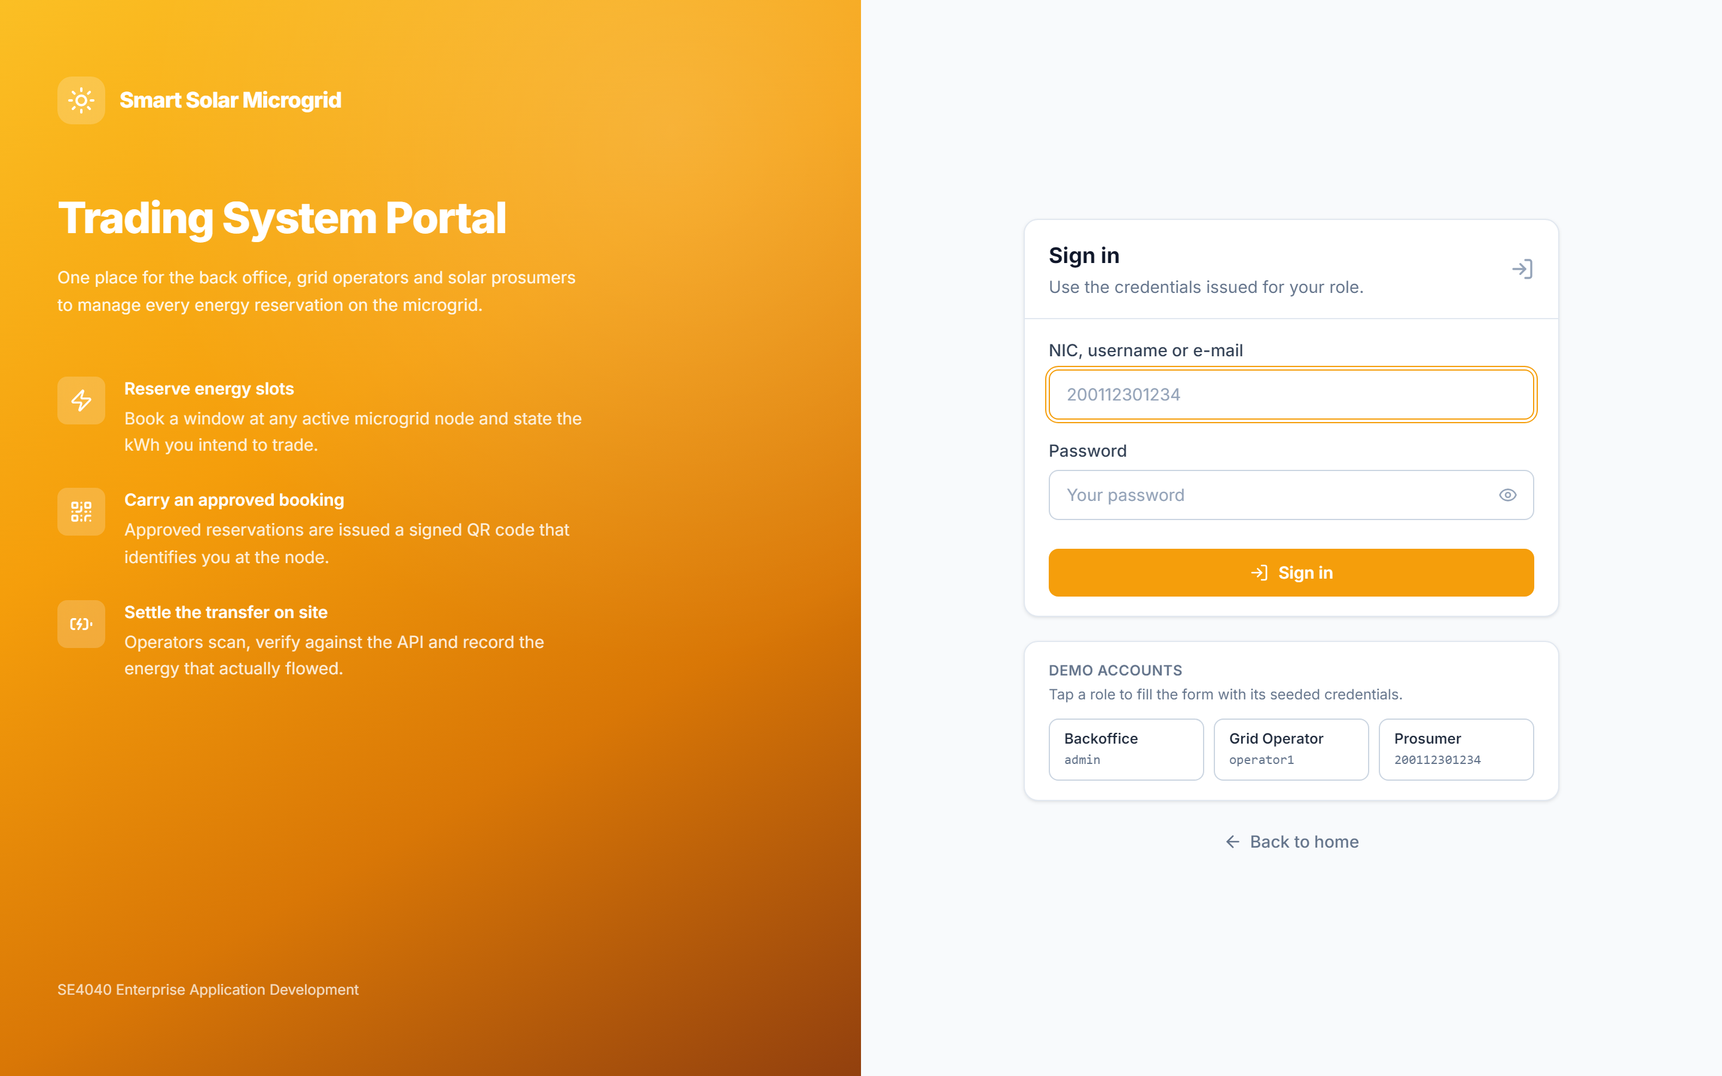
Figure 10. Role-aware login page with demonstration accounts

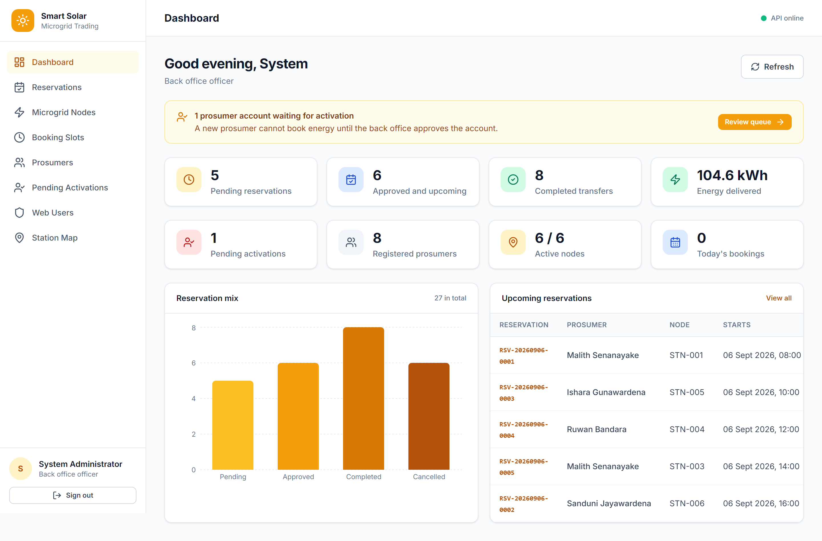
Figure 11. Backoffice dashboard with live system counters and reservation chart

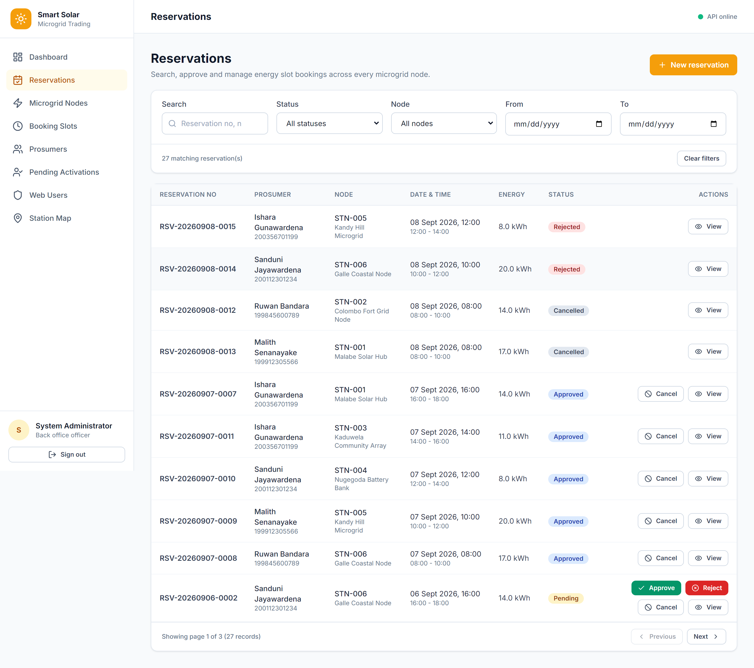
Figure 12. Reservation list with status, node, date and search filters

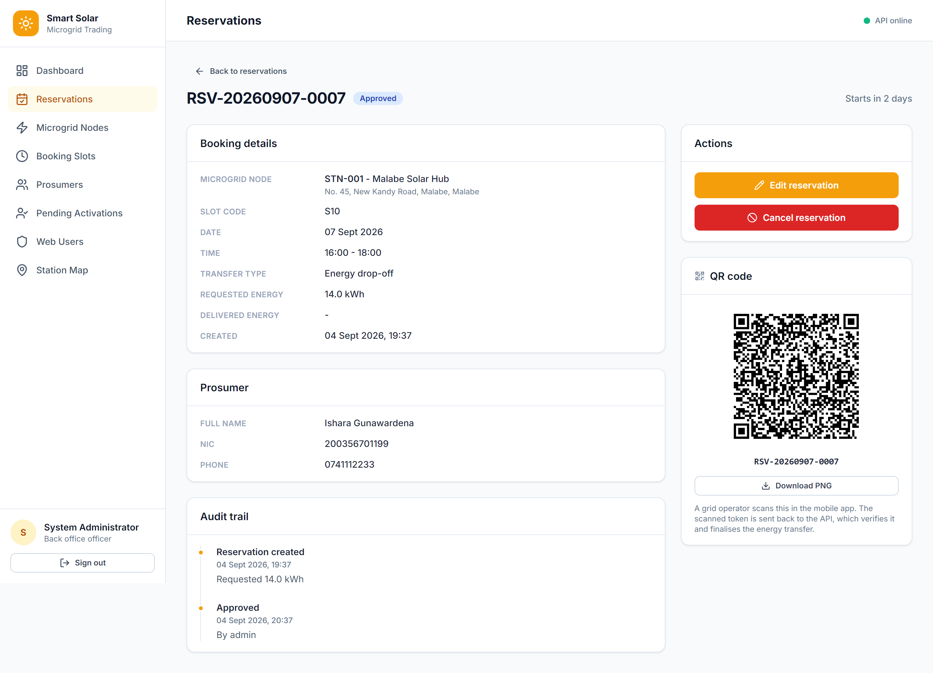
Figure 13. Reservation detail, audit trail and server-issued QR code

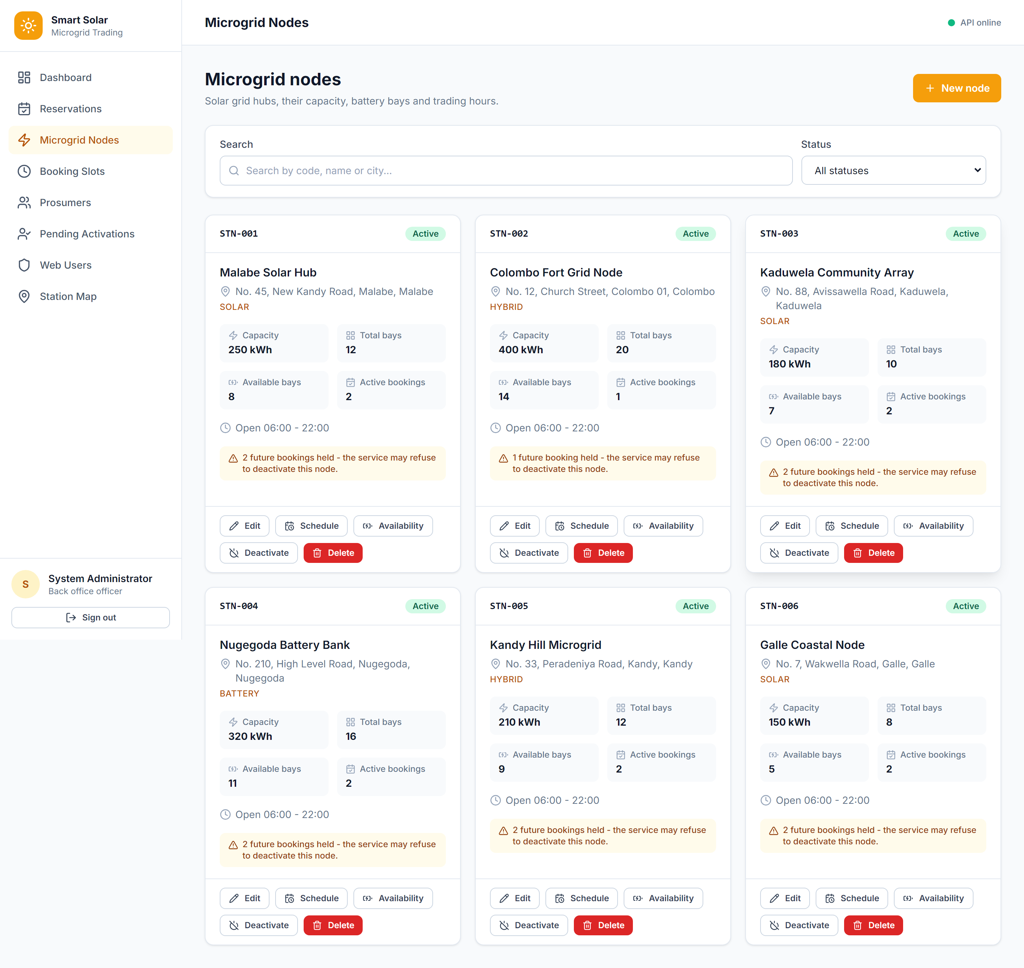
Figure 14. Microgrid node management with operational status and capacity

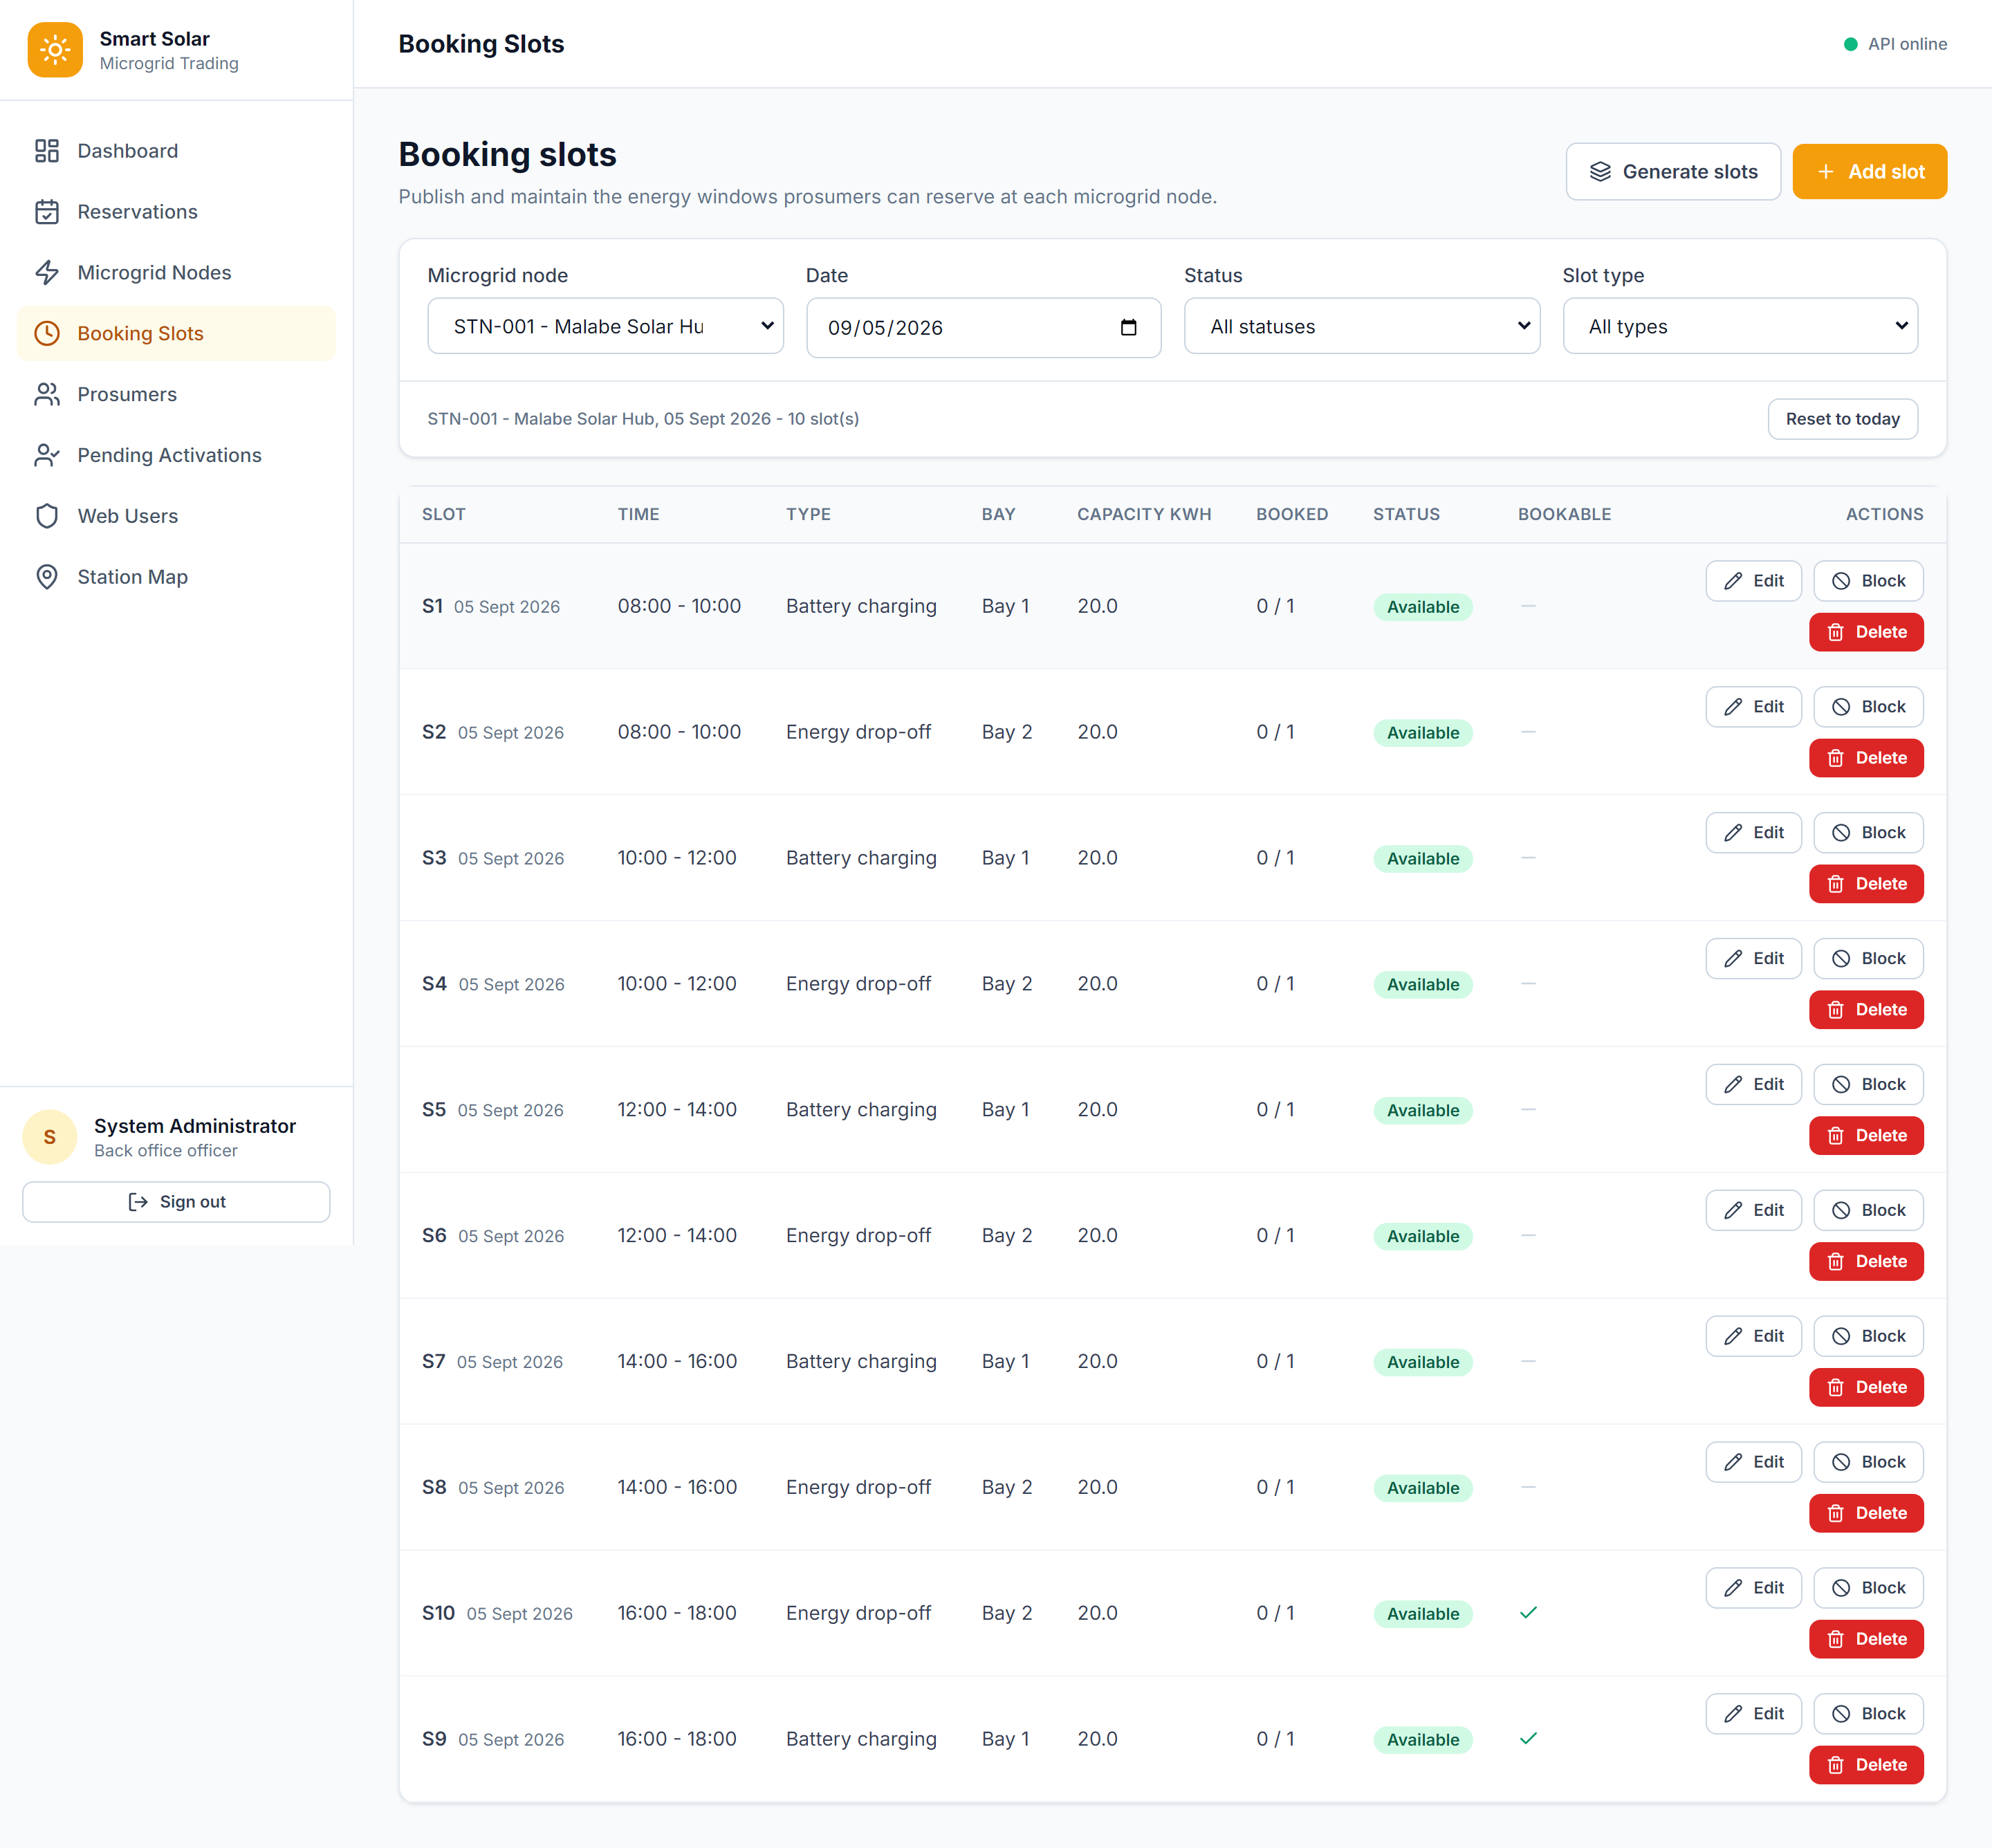
Figure 15. Booking-slot administration and availability controls

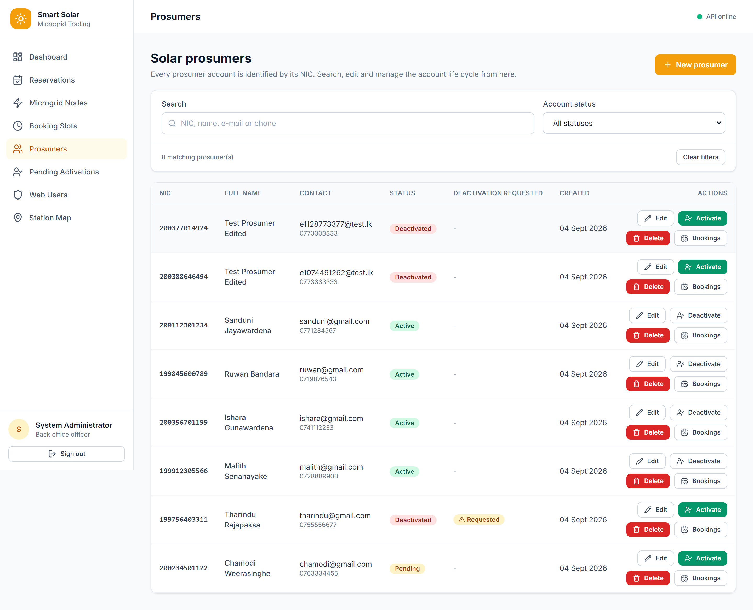
Figure 16. Prosumer management keyed by National Identity Card

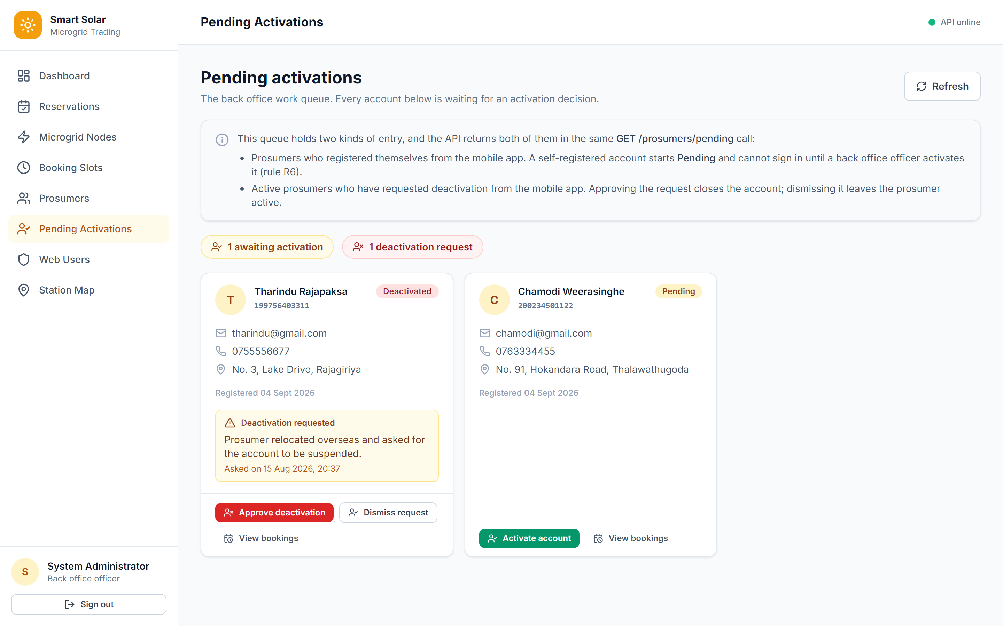
Figure 17. Pending activation and deactivation request queue

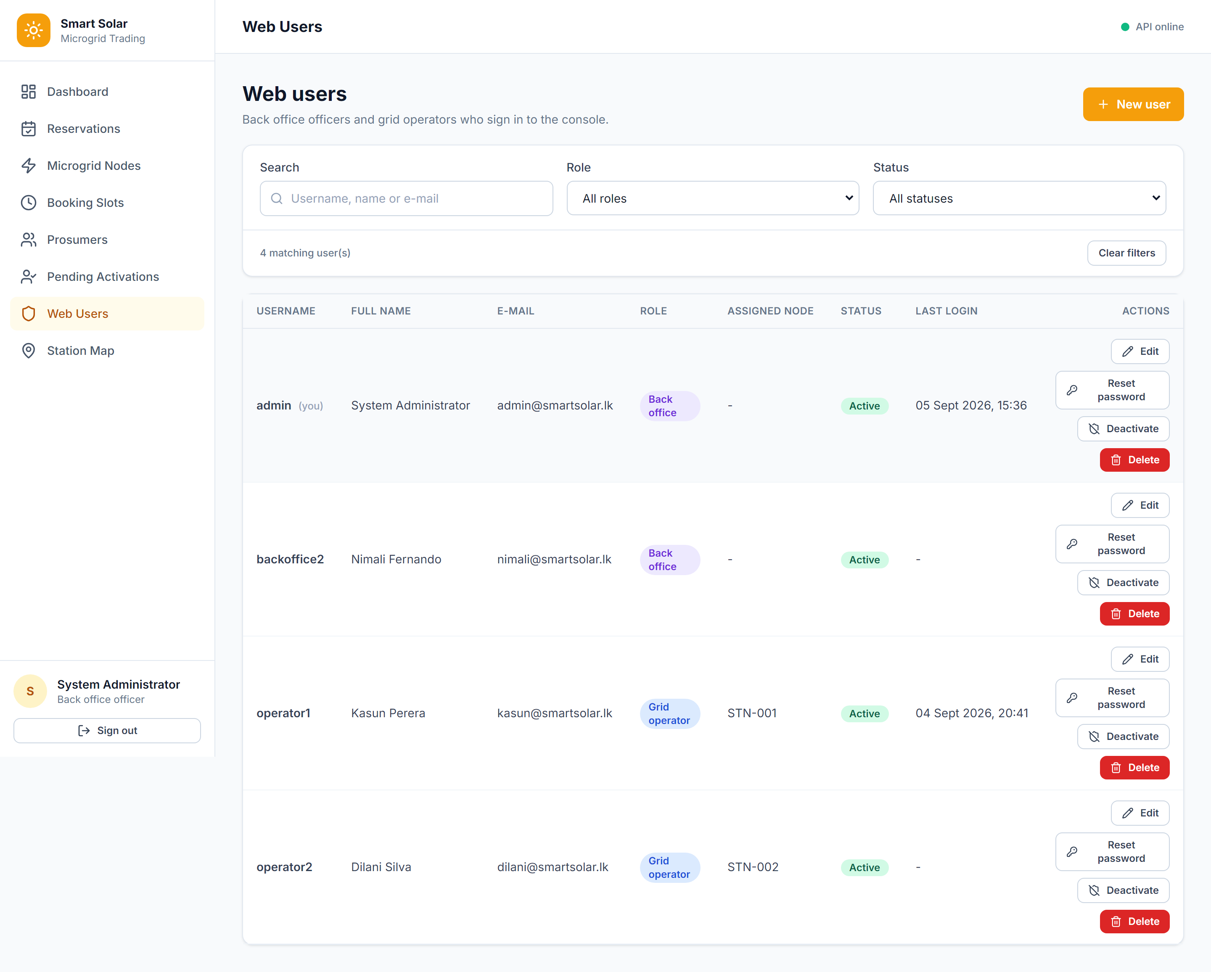
Figure 18. Backoffice administration of web users and roles

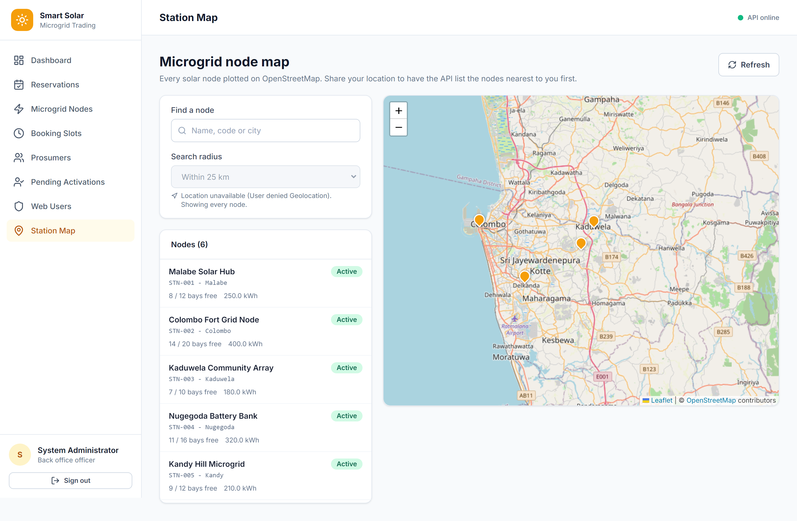
Figure 19. Microgrid map and nearby-node results

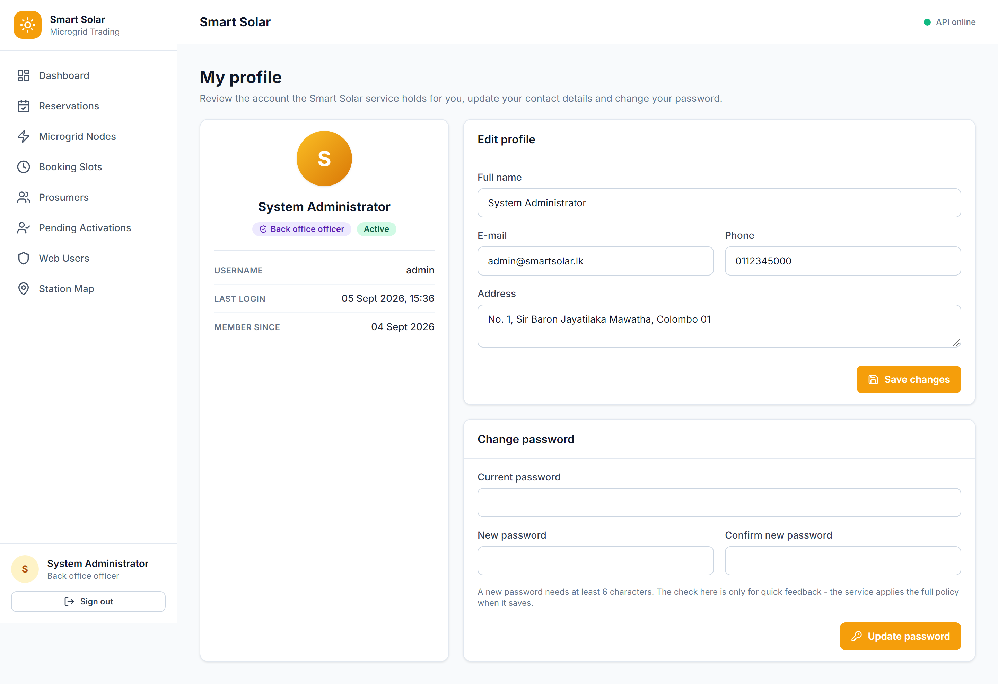
Figure 20. Profile maintenance and password change

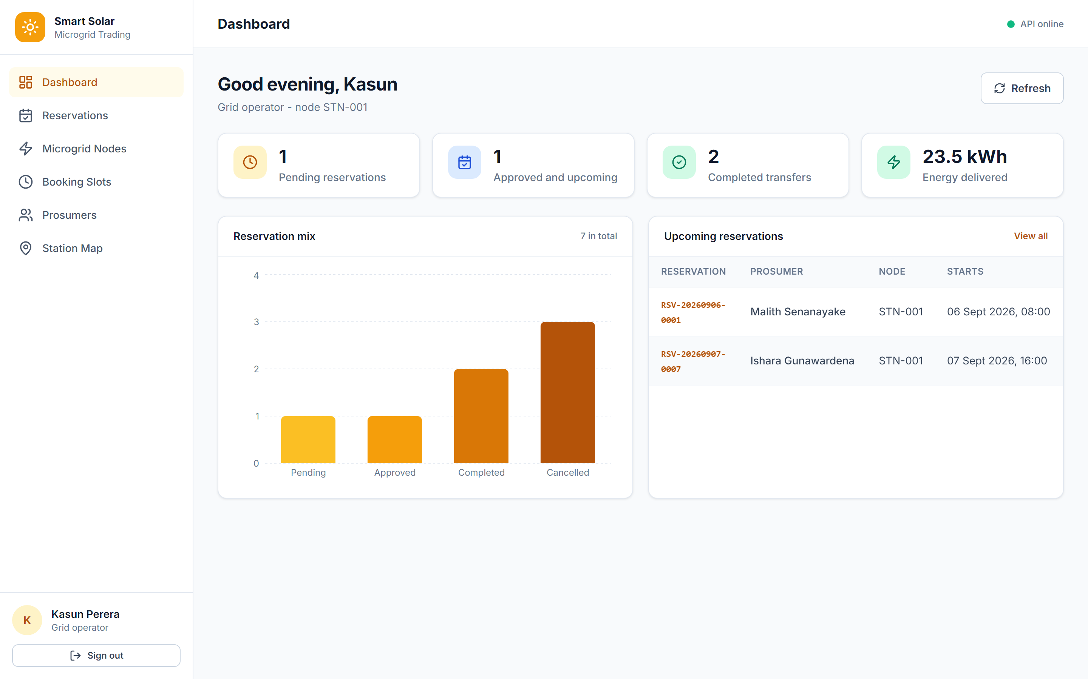
Figure 21. Grid-operator dashboard scoped to operational work

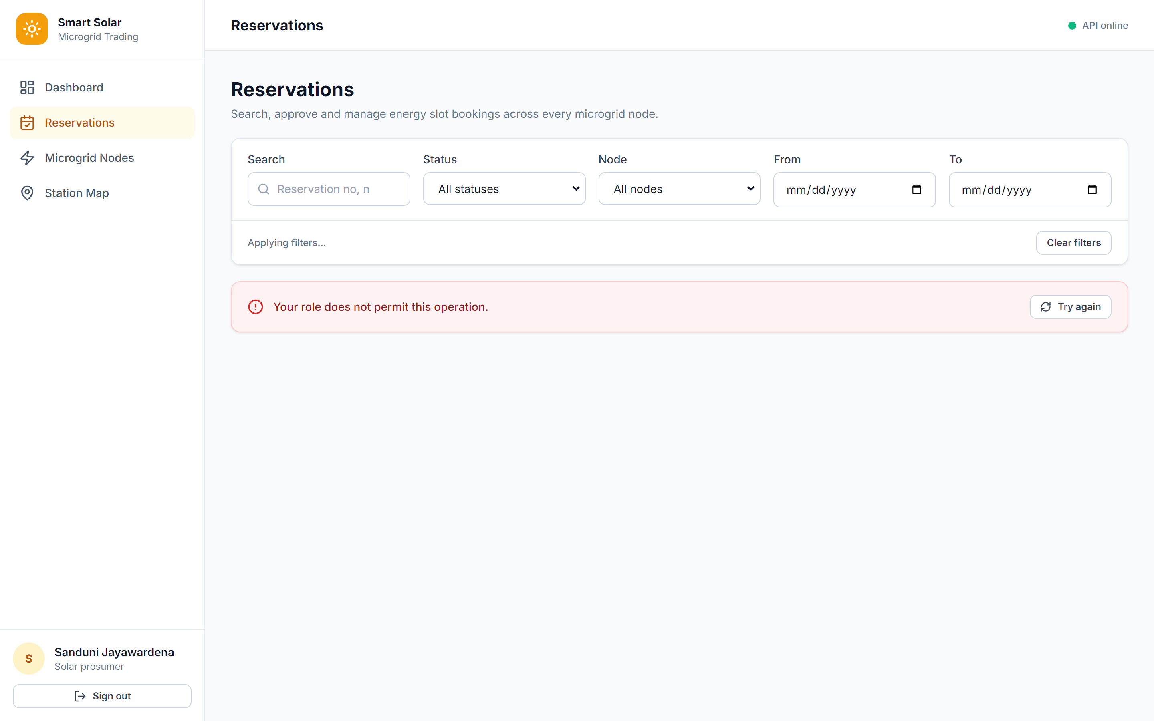
Figure 22. Prosumer reservation view with role-enforced restrictions

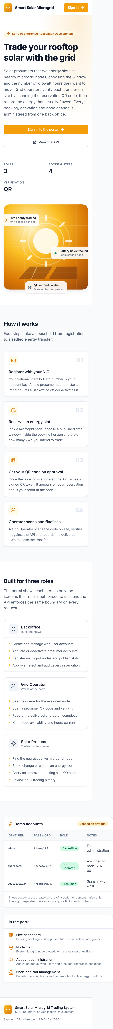
Figure 23a. Responsive public landing page at a mobile viewport, upper half

Figure 23b. Responsive public landing page at a mobile viewport, lower half

9.2 Mobile Application Interface Coverage
The native Android implementation contains the complete activity and XML-layout set listed below. The repository snapshot includes the capture procedure but does not contain Android screenshot image files. This distinction is retained so the report does not present generated mockups as executed mobile evidence.
Area | Activities | Evidence from implementation
Splash and authentication | SplashActivity, LoginActivity, RegisterActivity | SQLite session routing, role login and NIC registration
Prosumer dashboard | ProsumerHomeActivity | Live counters, quick actions and upcoming bookings
Reservation workflow | NewBookingActivity, EditBookingActivity, BookingSummaryActivity | Create, update and post-action summaries
Booking views | MyBookingsActivity, BookingDetailActivity | Current, pending and history views, search, QR display and server flags
Maps | StationsMapActivity, StationDetailActivity | Google Maps markers, nearby stations and details
Operator workflow | OperatorHomeActivity, OperatorBookingsActivity | Assigned-node dashboard, filtering and operational bookings
QR transfer | ScannerActivity, VerifyResultActivity | ZXing scan, server verification and transfer completion
Account | ProfileActivity | Profile edit, password change and deactivation request

10 Testing and Verification
Verification evidence is separated into repository-recorded results and checks executed while preparing this report. A successful historical result is not represented as a current rerun.

10.1 Repository Recorded Verification
Target | Recorded check | Recorded result | Current interpretation
Scripted API suite | 90 assertions | Recorded in docs/REPORT.md and README.md as 90 pass and 0 fail | Not rerun during this report build
Web API build | dotnet clean and dotnet build | Recorded as 0 warnings and 0 errors | Not rerun during this report build
Web production build | npm run build | Recorded as successful | Rerun; see current checks
Android debug build | gradlew assembleDebug | Recorded as successful | Rerun; see current checks

10.2 Current Local Checks on 29 September 2026
Area | Command or evidence | Result | Detail
Android | bash gradlew assembleDebug | PASS | 33 tasks executed; debug APK assembled. Java compiler reported deprecated API usage.
Web | npm ci then npm run build | PASS with warning | 2,258 modules transformed. Main JS bundle 913.73 kB; Vite reported a chunk-size warning.
Web dependencies | npm audit during npm ci | ATTENTION | npm reported 5 high-severity vulnerabilities. Dependency review is required before production deployment.
Web API | dotnet build | NOT RUN | The .NET SDK is not installed on this Mac.
Live API suite | docs/verify-api.ps1 | NOT RUN | The API was not available locally, and the installed Mongo shell is currently broken by a missing dynamic library.
Android screenshots | Repository inventory | NOT FOUND | No captured mobile screenshots are present under docs/screenshots.

10.3 Defects Found and Corrected During Development

Two defects found and fixed during testing
1. Misleading error on a duplicate booking. Attempting to book the same slot twice returned SLOT_UNAVAILABLE instead of DUPLICATE_RESERVATION, because the R8 capacity check ran before R13 and a single-booking slot was already full from the prosumer's own first booking. Fixed by reordering the checks in both CreateAsync and UpdateAsync so R13 evaluates first.
2. HTTP verb override was inert. The Android client falls back to POST + X-HTTP-Method-Override: PATCH on implementations that reject PATCH. The middleware that translates the header was registered after routing, so routing had already rejected the request with 405 before the header was read. The root cause is that WebApplication inserts UseRouting() at the start of the pipeline automatically when endpoints are mapped. Fixed by calling app.UseRouting() explicitly after the middleware, which suppresses the automatic insertion and pins routing to the correct position.

Three further defects found by the Android build
The mobile build surfaced three problems that no amount of reading would have caught:
1. `--` is not permitted inside an XML comment. Five layouts used ---- Section ----
dividers inside their comment blocks, which is illegal XML: only the closing --> may contain consecutive hyphens. AAPT rejected them with a bare ParseError naming only a row and column.
2. Implicit style inheritance. Widget.SmartSolar.StatusChip was declared without a
parent attribute. Android infers a style's parent from its dotted name when none is given, so it looked for Widget.SmartSolar - which does not exist - and resource linking failed. Adding an explicit parent="android:Widget.TextView" fixed it. This is a genuinely surprising rule and worth knowing.
3. A mismatched adapter callback. ProsumerHomeActivity implemented
ReservationAdapter.OnReservationClickListener with a method onReservationClick, while the adapter declares OnReservationClick with onClick. Two other screens used the correct names, so only one file was wrong.

11. Deployment
Full IIS instructions are in the README (../README.md#deploying-the-api-to-iis). In summary:
1. Install the .NET 8 Hosting Bundle on the server (without it IIS returns 500.19/500.31).
2. dotnet publish SmartSolar.Api -c Release -o C:\inetpub\SmartSolarApi
3. Create an application pool with No Managed Code, and a site pointing at that folder.
4. Grant the pool identity read/execute on the folder.
5. Set MongoDbSettings:ConnectionString in the published appsettings.json.
6. Verify http://<host>/api/v1/health reports "database": "Connected".
7. Repoint VITE_API_BASE_URL and API_BASE_URL_DEBUG, then rebuild both clients.

12 Source Code Extracts
The submitted repository contains the complete source tree. The following copied text listings present representative implementation evidence for the central service, MongoDB access, React client, native Android networking and SQLite persistence. They are text listings rather than source-code screenshots, as required by the assignment brief.

ASP.NET Core request pipeline and central-service wiring - backend/SmartSolar.Api/Program.cs
Listing 1. ASP.NET Core request pipeline and central-service wiring - backend/SmartSolar.Api/Program.cs
app.UseExceptionHandlingMiddleware();
// The verb override MUST run before routing, otherwise routing has already rejected
// the POST with 405 by the time the header is read.
//
// Note the explicit UseRouting() below. WebApplication normally inserts UseRouting()
// automatically at the very START of the pipeline when endpoints are mapped, which
// would place it ahead of this middleware and defeat it. Calling UseRouting()
// explicitly suppresses that automatic insertion and pins routing to this position.
app.UseMethodOverride();
app.UseRouting();
// Swagger is left enabled outside Development as well, because the marker needs
// a way to exercise the API on the IIS deployment.
app.UseSwagger();
app.UseSwaggerUI(options =>
{
options.SwaggerEndpoint("/swagger/v1/swagger.json", "Smart Solar Microgrid API v1");
options.DocumentTitle = "Smart Solar Microgrid Trading System - API";
});
app.UseCors(CorsPolicy);
app.UseAuthentication();
app.UseAuthorization();
app.MapControllers();

Seven-day reservation guard - backend/SmartSolar.Api/Services/Implementations/ReservationService.cs
Listing 2. Seven-day reservation guard - backend/SmartSolar.Api/Services/Implementations/ReservationService.cs
if (slot.StartUtc <= now || slot.StartUtc > now.AddDays(WindowDays))
{
return ServiceResult<bool>.Invalid(
$"Reservations must be scheduled within the next {WindowDays} days and cannot be in the past.",
ErrorCodes.ReservationWindow);
}
// ***RULE R12*** - the node publishes a seven day schedule, and a day marked closed cannot be booked.
// DayOfWeek is 0 = Sunday, which is exactly how the schedule rows are numbered.
var dayIndex = (int)slot.StartUtc.DayOfWeek;
var daySchedule = station.WeeklySchedule.FirstOrDefault(d => d.DayOfWeek == dayIndex);
if (daySchedule is not null && !daySchedule.IsOpen)
{
return ServiceResult<bool>.Invalid(
$"The microgrid node {station.StationCode} is closed on {DomainMapper.DayName(dayIndex)}. " +

Twelve-hour cancellation guard - backend/SmartSolar.Api/Services/Implementations/ReservationService.cs
Listing 3. Twelve-hour cancellation guard - backend/SmartSolar.Api/Services/Implementations/ReservationService.cs
// ***RULE R3*** - the same 12 hour notice the update rule uses, so an operator is never left with
// a slot that empties minutes before the prosumer was due to arrive.
var hoursUntilStart = (reservation.ReservationStartUtc - now).TotalHours;
if (hoursUntilStart < NoticeHours)
{
_logger.LogInformation(
"R3 blocked a cancellation of {ReservationNo}: {Hours} hour(s) of notice remained.",
reservation.ReservationNo, Math.Round(hoursUntilStart, 2));
return ServiceResult<ReservationDto>.Invalid(
$"Reservations can only be cancelled at least {NoticeHours} hours before the scheduled start time.",
ErrorCodes.ReservationCancelNotice);
}
var update = Builders<EnergyReservation>.Update
.Set(r => r.Status, ReservationStatus.Cancelled)
.Set(r => r.CancelledBy, caller.Username)
.Set(r => r.CancelledAt, now)

MongoDB collection and index initialization - backend/SmartSolar.Api/Data/MongoDbContext.cs
Listing 4. MongoDB collection and index initialization - backend/SmartSolar.Api/Data/MongoDbContext.cs
public async Task EnsureIndexesAsync(CancellationToken ct = default)
{
// CreateMany is idempotent - an index that already exists with the same shape is left alone.
try
{
await Users.Indexes.CreateManyAsync(new[]
{
// NIC is the prosumer primary key: unique, but sparse so web users may omit it.
new CreateIndexModel<User>(
Builders<User>.IndexKeys.Ascending(u => u.Nic),
new CreateIndexOptions { Unique = true, Sparse = true, Name = "ux_users_nic" }),
new CreateIndexModel<User>(
Builders<User>.IndexKeys.Ascending(u => u.Username),
new CreateIndexOptions { Unique = true, Name = "ux_users_username" }),
new CreateIndexModel<User>(
Builders<User>.IndexKeys.Ascending(u => u.Email),
new CreateIndexOptions { Unique = true, Sparse = true, Name = "ux_users_email" }),
new CreateIndexModel<User>(
Builders<User>.IndexKeys.Ascending(u => u.Role).Ascending(u => u.Status),
new CreateIndexOptions { Name = "ix_users_role_status" })
}, ct);
await Stations.Indexes.CreateManyAsync(new[]
{
new CreateIndexModel<SolarStationInfo>(
Builders<SolarStationInfo>.IndexKeys.Ascending(s => s.StationCode),
new CreateIndexOptions { Unique = true, Name = "ux_stations_code" }),
new CreateIndexModel<SolarStationInfo>(
Builders<SolarStationInfo>.IndexKeys.Ascending(s => s.Status),
new CreateIndexOptions { Name = "ix_stations_status" })
}, ct);
await Slots.Indexes.CreateManyAsync(new[]
{
new CreateIndexModel<EnergyBookingSlot>(
Builders<EnergyBookingSlot>.IndexKeys
.Ascending(s => s.StationId)
.Ascending(s => s.SlotDate)
.Ascending(s => s.SlotCode),
new CreateIndexOptions { Unique = true, Name = "ux_slots_station_date_code" }),
new CreateIndexModel<EnergyBookingSlot>(
Builders<EnergyBookingSlot>.IndexKeys.Ascending(s => s.StartUtc),

Centralized React error handling - web/src/api/client.ts
Listing 5. Centralized React error handling - web/src/api/client.ts
http.interceptors.response.use(
(response) => response,
(error: AxiosError<ApiResponse<unknown>>) => {
// No response at all means DNS, CORS, a timeout or a stopped API.
if (!error.response) {
return Promise.reject(
new ApiError(
'Could not reach the Smart Solar service. Please confirm the API is running.',
0,
'NETWORK_ERROR',
),
);
}
const { status, data } = error.response;
return Promise.reject(
new ApiError(
data?.message ?? `The request failed with HTTP ${status}.`,
status,
data?.errorCode ?? null,
data?.errors ?? null,
),
);
},
);
/**
* Unwraps the envelope and returns the payload. A response whose success flag is
* false is turned into an ApiError, so a caller that awaits this function only
* ever receives real data.
*/
export async function unwrap<T>(promise: Promise<{ data: ApiResponse<T> }>): Promise<T> {
// The envelope is uniform, so one unwrapper serves every endpoint.
const response = await promise;
const body = response.data;
if (!body.success) {
throw new ApiError(body.message, 200, body.errorCode, body.errors);

Native Android asynchronous API execution - mobile/app/src/main/java/lk/sliit/smartsolar/api/ApiClient.java
Listing 6. Native Android asynchronous API execution - mobile/app/src/main/java/lk/sliit/smartsolar/api/ApiClient.java
private void enqueue(final String method, final String path, final JSONObject body,
final String token, final Callback callback) {
// A connectivity check up front turns a 20 second timeout into an instant message.
if (!isOnline()) {
MAIN_HANDLER.post(() -> callback.onResult(
ApiResult.networkFailure("No internet connection. Please check your network and try again.")));
return;
}
EXECUTOR.execute(() -> {
final ApiResult result = execute(method, path, body, token);
MAIN_HANDLER.post(() -> callback.onResult(result));
});
}
/** Performs the blocking HTTP call. Runs on a background thread only. */
private ApiResult execute(String method, String path, JSONObject body, String token) {
// Everything in this method is deliberately synchronous - the caller already backgrounded it.
HttpURLConnection connection = null;
try {
URL url = new URL(baseUrl + path);
connection = (HttpURLConnection) url.openConnection();
// Android accepts PATCH directly; the catch is the safety net for any
// implementation that does not, and the API understands both forms.
try {
connection.setRequestMethod(method);
} catch (java.net.ProtocolException protocolEx) {
Log.w(TAG, "Request method " + method + " rejected; falling back to POST override.", protocolEx);
connection.setRequestMethod("POST");
connection.setRequestProperty("X-HTTP-Method-Override", method);
}
connection.setConnectTimeout(CONNECT_TIMEOUT_MS);

SQLite session table definition - mobile/app/src/main/java/lk/sliit/smartsolar/db/DatabaseHelper.java
Listing 7. SQLite session table definition - mobile/app/src/main/java/lk/sliit/smartsolar/db/DatabaseHelper.java
private static final String CREATE_SESSION =
"CREATE TABLE " + TABLE_SESSION + " (" +
COL_SESSION_ID + " INTEGER PRIMARY KEY, " +
COL_SESSION_USER_ID + " TEXT NOT NULL, " +
COL_SESSION_NIC + " TEXT, " +
COL_SESSION_USERNAME + " TEXT NOT NULL, " +
COL_SESSION_FULL_NAME + " TEXT, " +
COL_SESSION_EMAIL + " TEXT, " +
COL_SESSION_PHONE + " TEXT, " +
COL_SESSION_ADDRESS + " TEXT, " +
COL_SESSION_ROLE + " TEXT NOT NULL, " +
COL_SESSION_STATUS + " TEXT, " +
COL_SESSION_STATION_ID + " TEXT, " +
COL_SESSION_STATION_CODE + " TEXT, " +
COL_SESSION_TOKEN + " TEXT NOT NULL, " +
COL_SESSION_EXPIRES_AT + " TEXT, " +
COL_SESSION_SAVED_AT + " INTEGER NOT NULL)";
private static final String CREATE_STATIONS =
"CREATE TABLE " + TABLE_STATIONS + " (" +
COL_STATION_ID + " TEXT PRIMARY KEY, " +
COL_STATION_CODE + " TEXT NOT NULL, " +
COL_STATION_NAME + " TEXT NOT NULL, " +
COL_STATION_TYPE + " TEXT, " +
COL_STATION_ADDRESS + " TEXT, " +
COL_STATION_CITY + " TEXT, " +
COL_STATION_LAT + " REAL NOT NULL DEFAULT 0, " +
COL_STATION_LNG + " REAL NOT NULL DEFAULT 0, " +
COL_STATION_CAPACITY + " REAL NOT NULL DEFAULT 0, " +
COL_STATION_TOTAL_SLOTS + " INTEGER NOT NULL DEFAULT 0, " +
COL_STATION_AVAILABLE_SLOTS + " INTEGER NOT NULL DEFAULT 0, " +
COL_STATION_CONTACT + " TEXT, " +
COL_STATION_STATUS + " TEXT, " +
COL_STATION_CACHED_AT + " INTEGER NOT NULL)";

13 Individual Contributions and AI Disclosure

13.1 Contribution Evidence
The Git history supplied with this repository attributes implementation commits to the shared identity SmartSolar Team and the report-cover commit to AKAZJAYA. It therefore does not provide reliable person-by-person implementation attribution. The four members must confirm their own distinct contribution statements before submission; the report does not infer ownership from name order.
IT Number | Name | Contribution statement
IT22207272 | Fonseka G N V S | Member-specific contribution statement requires confirmation by the named member.
IT22228062 | Jayasinghe I A S A | Member-specific contribution statement requires confirmation by the named member.
IT22049872 | Navod W D C | Member-specific contribution statement requires confirmation by the named member.
IT22246332 | Hettiarachchi H A S L | Member-specific contribution statement requires confirmation by the named member.

Implementation areas that require explicit allocation are: API authentication and account services; station, slot, reservation, QR and MongoDB work; the React web client; the native Android, SQLite, Maps and QR client; testing; diagrams; documentation; and deployment.

13.2 AI Use Disclosure
The assignment brief classifies this assessment as AI Assessment Scale Level 2 - AI Planning. Member-specific AI-use disclosures and reflections are not present in the repository evidence. Each member is responsible for recording the tools actually used, the permitted planning purpose, how the output was evaluated, and how the final design and implementation were independently understood and developed. This report was assembled from the repository with AI assistance and must be reviewed against the module policy before submission.

14. Challenges
Keeping business logic out of the clients. The FAT-service constraint is easy to state and easy to violate accidentally - the natural instinct when writing a Cancel button is to check the time locally and hide it. The approach that made the rule hold was to stop sending the clients the inputs to a rule and send them the answer instead: canModify and canCancel are computed server-side per record, and the clients only enable or disable a control. Slot availability was solved the same way with isBookable.
Rule ordering changes the user experience. Both R8 and R13 correctly rejected a duplicate booking, but in the wrong order the user was told "this slot is full" when the truth was "you already booked this slot". Getting a rule right is not the same as getting it helpful.
Pipeline ordering in ASP.NET Core. The verb-override middleware was correct but never ran in time, because WebApplication silently inserts UseRouting() at the front of the pipeline. Only an explicit app.UseRouting() moves it. This cost real debugging time and was only caught because the test suite asserted on the override path.
Cross-platform QR rendering. The obvious QRCoder renderer depends on System.Drawing.Common, which is Windows-only on .NET 8. PngByteQRCode produces PNG bytes with no platform graphics dependency, and rendering server-side means the phone needs no QR encoding library at all - only a scanner.
Unique indexes over optional fields. A plain unique index on nic rejects a second staff account, because two documents with nic: null collide. Marking the index sparse scopes uniqueness to documents that actually have the field, which is precisely the requirement.
Denormalisation and consistency. Copying stationName onto reservations removes an N+1 query on every list screen, but creates a consistency obligation: renaming a node has to propagate. StationService.UpdateAsync does that explicitly with UpdateManyAsync.
Time zones. Storing wall-clock strings alone made every rule ambiguous. Storing both a display string and an absolute startUtc, and having every rule compare only on the absolute value, removed a whole class of bugs. Reading "now" through an injected IClock rather than DateTime.UtcNow made the rules testable.
QR replay. A screenshotted QR code is trivially reusable. Two mitigations: the token is cleared when a transfer completes, and it is re-issued if an approved booking is moved to a different slot.

15. References
1. Microsoft. ASP.NET Core Web API documentation. <https://learn.microsoft.com/aspnet/core/web-api/>
2. Microsoft. Host ASP.NET Core on Windows with IIS. <https://learn.microsoft.com/aspnet/core/host-and-deploy/iis/>
3. Microsoft. Hash passwords in ASP.NET Core. <https://learn.microsoft.com/aspnet/core/security/data-protection/consumer-apis/password-hashing>
4. Microsoft. Middleware in ASP.NET Core. <https://learn.microsoft.com/aspnet/core/fundamentals/middleware/>
5. MongoDB. MongoDB C#/.NET Driver - Fundamentals. <https://www.mongodb.com/docs/drivers/csharp/current/fundamentals/>
6. MongoDB. Indexes. <https://www.mongodb.com/docs/manual/indexes/>
7. MongoDB. Update Operators - `$inc`. <https://www.mongodb.com/docs/manual/reference/operator/update/inc/>
8. Android Developers. Save data using SQLite. <https://developer.android.com/training/data-storage/sqlite>
9. Android Developers. Connect to the network. <https://developer.android.com/develop/connectivity/network-ops/connecting>
10. Android Developers. Request runtime permissions. <https://developer.android.com/training/permissions/requesting>
11. Google. Maps SDK for Android. <https://developers.google.com/maps/documentation/android-sdk/overview>
12. Google. Fused Location Provider API. <https://developers.google.com/location-context/fused-location-provider>
13. JourneyApps. ZXing Android Embedded. <https://github.com/journeyapps/zxing-android-embedded>
14. Codebude. QRCoder. <https://github.com/codebude/QRCoder>
15. React. React 18 documentation. <https://react.dev/>
16. Tailwind Labs. Tailwind CSS documentation. <https://tailwindcss.com/docs>
17. Remix Run. React Router v6. <https://reactrouter.com/>
18. Recharts. Recharts documentation. <https://recharts.org/>
19. Vladimir Agafonkin. Leaflet. <https://leafletjs.com/>
20. OpenStreetMap Foundation. Tile usage policy. <https://operations.osmfoundation.org/policies/tiles/>
21. Veness, C. Calculate distance and bearing between two Latitude/Longitude points (Haversine). <https://www.movable-type.co.uk/scripts/latlong.html>
22. IETF. RFC 7519 - JSON Web Token (JWT). <https://datatracker.ietf.org/doc/html/rfc7519>
23. OWASP. Password Storage Cheat Sheet. <https://cheatsheetseries.owasp.org/cheatsheets/Password_Storage_Cheat_Sheet.html>
Submitted for SE4040 Enterprise Application Development, 2026.

Appendix A API Endpoint Catalogue
Base path: /api/v1. The full request and response contract is maintained in docs/API_CONTRACT.md.
Controller | Operations | Access
Auth | POST /auth/login; POST /auth/register; GET /auth/me; POST /auth/change-password | Anonymous for login and registration; authenticated for profile and password
Users | GET/POST /users; GET/PUT/DELETE /users/{id}; PATCH activate/deactivate; POST reset-password | Backoffice
Prosumers | GET /prosumers; GET pending; GET/PUT /{nic}; POST; PATCH activate/deactivate; POST request-deactivation; DELETE | Backoffice, GridOperator and owner rules
Stations | GET; GET nearby; GET /{id}; POST; PUT; PATCH schedule/availability/activate/deactivate; DELETE | Authenticated; mutations role-restricted
Slots | GET; GET available; GET /{id}; POST; POST generate; PUT; PATCH block; DELETE | Authenticated; mutations Backoffice or GridOperator
Reservations | GET; GET my/history/dashboard/{id}/{id}/qr; POST; PUT; PATCH cancel/approve/reject; POST verify-qr/complete | Owner and staff policies enforced in controller and service
Health | GET /health | Anonymous

Appendix B Submission Readiness
Deliverable | Status | Evidence or action
Detailed report | Prepared | This document extends the supplied cover with the project analysis and evidence.
Web UI screenshots | Present | 15 unique captures included from docs/screenshots/web.
Android UI screenshots | Outstanding | Capture from an emulator or device using docs/CAPTURE_MOBILE_SCREENSHOTS.md.
Main opening-screen screenshot | Outstanding | Capture the Android prosumer home screen.
High-level, use case and DFD diagrams | Present | Rendered from docs/diagrams/DIAGRAMS.md.
Database design | Present | Four MongoDB collections, indexes, relationships and SQLite cache described.
Source code as text | Present | Representative copied listings included; full source remains in the submission archive.
Git repository link | Present | https://github.com/wahallu/SmartSolarMicrogridTradingSystem
Individual contributions | Outstanding | Each named member must confirm a distinct factual statement.
AI disclosure and reflection | Outstanding | Each member must complete an accurate policy-aligned disclosure.
Demonstration video | Outstanding | Add a YouTube or OneDrive link to README before submission.
IIS and live API proof | Not currently verified | The report documents the deployment procedure; current live deployment evidence is not present.

